Table of Contents

[Director’s Comments 3](#_Toc457584059)

[Highlights 4](#_Toc457584060)

[Executive Summary 5](#_Toc457584061)

[Research ..7](#_Toc457584062)

[Research Projects 9](#_Toc457584063)

[Student Vignettes 24](#_Toc457584064)

[External Funding and Collaborating Partners 30](#_Toc457584065)

[Communication 35](#_Toc457584066)

[In the News 37](#_Toc457584067)

[Publications 44](#_Toc457584068)

[Organization 45](#_Toc457584069)

[Personnel 47](#_Toc457584070)

[Charter 55](#_Toc457584071)

[Capabilities, Equipment, and Facilities 57](#_Toc457584072)

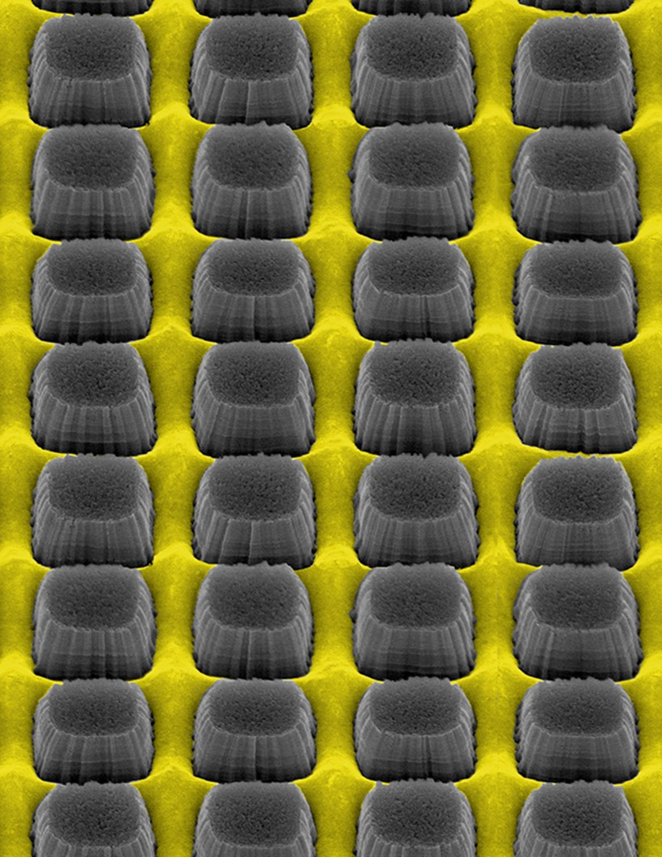

# Director’s Comments

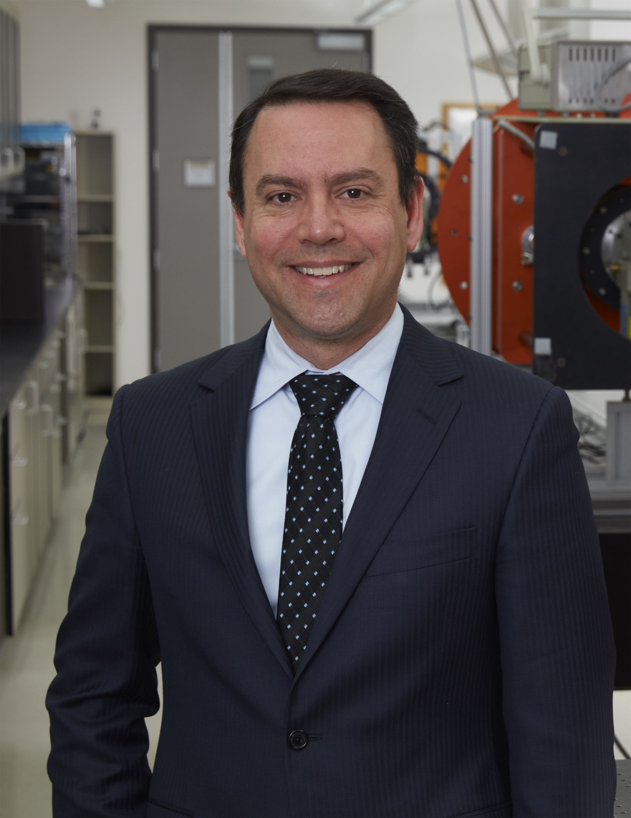 The Center for Detectors, a Research Center within the Rochester Institute of Technology’s College of Science, continued to expand its scope to include development of new material systems and integrated silicon photonics. In our sixth year, the CfD led many research developments, including studying the radio frequency performance of a III–V transistor and proving chip-level electrical uniformity of planar nanowire (NW) array-based transistors, and using a combined analysis of the infrared spectra of extraordinarily luminous stars near the Galactic center.

As in previous years, the CfD engages students from a variety of majors. These student researchers are eager to participate in center’s research because their experiences are authentically connected to world class research and development. Students take on direct responsibility in our projects, they are integral players in an interdisciplinary research team. As I tell the students when they first start in the CfD, “Check your major at the door – your new major is ‘solving problems’.”

The world got a bit bigger for the CfD last year, becoming part of the Future Photon Initiative (FPI), a new center that is the face of photonics for the Rochester Institute of Technology. The FPI leverages existing research activities of over 20 RIT professors in pursuit of advancing new photonic devices, such as detectors, integrated silicon photonics, and solar cells. The research groups in the FPI address the “big” questions of humanity, Are we alone in the Universe? What is the nature of dark energy and dark matter? How does the human brain develop? Can we improve outcomes for breast cancer survivors?

In July 2015, A New York-based consortium was awarded a multimillion-dollar federal investment to create a national photonics center in Rochester. The American Institute for Manufacturing Integrated Photonics (AIM Photonics) focuses on the design, manufacture, testing, assembly and packaging of integrated photonic devices. RIT is a Tier 1 Academic Partner of AIM Photonics, and FPI is the lead RIT organization that will interface with AIM.

The following Annual Report describes the new and exciting activities of the Center of the past year. In it, you will find descriptions of CfD research, education, and outreach programs. I welcome your interest in the CfD and look forward to your support and feedback.

|  |
| --- |
|  |
|  |
| Dr. Donald Figer  Professor, RIT College of Science  Director, Center for Detectors |

# Highlights

# Executive Summary

This report summarizes activities in the Center for Detectors (CfD) over the past year, spanning July, 2015 through June, 2016. The purpose of the Center is to develop and implement advanced photon devices to enable scientific discovery, national security, and better living. These objectives are met through leveraging multi-disciplinary and symbiotic relationships between its students, staff, faculty, external partners, and by pursuing projects with personnel from multiple colleges, departments, companies, and national laboratories. The CfD was established in January, 2010. It is an Academic Research Center within the College of Science at the Rochester Institute of Technology.

## Personnel

CfD members come from a wide range of academic programs and professional occupations. Personnel this year included six Professors, two engineers, three student laboratory assistants, five laboratory research students, ten PhD students, and other support staff.

## Student Vignettes

Many of the students do research in the Center’s laboratories for their academic programs. The Center welcomed five new graduate students, including Thomas Wilhelm and Mohadeseh A. Baboli, both in the Microsystems Engineering PhD program.

## Publications

In the past year, CfD researchers submitted nine papers for publication. In May 2016, a publication co-authored by Dr. Mohseni, Assistant Professor of the Microsystems Engineering Ph.D. Program, titled “Evolution of GaAs Nanowire Geometry by Selective Area Epitaxy,” was chosen as a “recent favorite” by Applied Physics Letters Associate Editor, Prof. Kei May Lau.

## Projects and External Funding

The Center is grant-funded, and has been awarded more than $16M in research funding since 2006. New projects this year include “Phase II: New Infrared Detectors for Astrophysics” ($2M) funded by the National Science Foundation, and the “Integrated Quantum Photonics for Photon-Ion Entanglement” project ($600K) funded by USAF. Continuing this year are “The Development of Digital Mircomirror Devices for use in Space” ($565K) funded by NASA and “New Infrared Detectors for Astrophysics” ($1.5M) funded by NSF. Completed this year, was the “Next Generation Imaging Detectors for Near- and Mid- IR Wavelength Telescopes” ($3M) project, funded by the Gordon and Betty Moore Foundation.

## Equipment and Facilities

The Center for Detectors (CfD) is located in the IT Collaboratory and has large contiguous spaces for offices and labs, including offices for 17 people, and four research laboratories. The laboratories include the Rochester Imaging Detector Laboratory, a suborbital rocket lab, and an integrated nanophotonics lab.

|  |
| --- |
|  |
| Research |

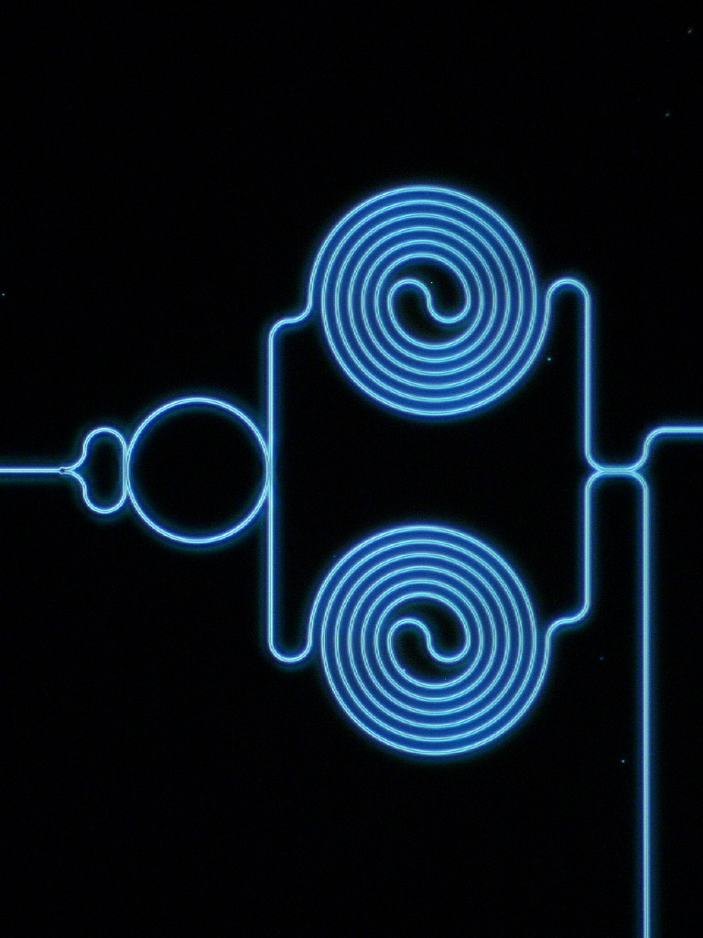

# Research Projects

### Cosmic Ray Damaged Image Repair (CRDIR)

#### Private Donations

#### Donald Figer

The Cosmic Ray Damaged Image Repair project was first imagined by NASA astronaut, Donald Pettit, RIT alum, Peter A Blacksberg (BFA Photo '75), and Center for Detectors (CfD) Director, Don Figer. Donald Pettit is a prolific photographer on the International Space Station (ISS). During a trip to RIT in April of 2015, organized by Mr. Blacksberg, he visited the CfD to discuss a persistent problem with the images. They are riddled with the effects of pixels damaged by cosmic rays. The three principals agreed to form a collaborative project to clean (“retouch the bad spots” in photography parlance) the images of these effects. Many different student researchers have contributed to the project: Joseph DiPassio (Electrical Engineering), Neil Geurten (Computational Mathematics and Computer Science), Aravind Warrier (Computer Science), Gilford Fernandes (Computer Science), and Kevin Moser (Imaging Science).

The main goal of the project is to remove noise that plagues images taken on ISS. Astronauts began solely using digital Nikon professional cameras to document activities both inside and outside the ISS after changing from film photography to digital cameras, which was mandated after the loss of Space Shuttle Columbia in 2003. Pixels are damaged by high energy cosmic rays and produce high signal levels due to enhanced dark current. In this project, bad pixels are located using a combination of detection methods and replaced with the median of a local neighborhood. One key objective of this project is to design an easy user interface to integrate with NASA’s image processing.

|  |
| --- |
|  |
| http://aishack.in/static/img/tut/conv-laplacian.jpg |
| Figure . The Laplacian operator used to find single high intensity pixel associated with hot pixel damage. |
|  |

CRDIR progress was based on the work done in the previous years. In the past, various algorithms were created to clean these images with varying degrees of success. The first step of the project was to identify damaged pixels. To do this, a Python program was created to display small sections of an image and allow a user to mark visually distinct pixels from the background. Allowing a user to make the selection removed false positives from objects in the scene such as stars and helps to ensure the removal of visually damaging pixels.

The primary detection algorithm determines if a pixel is much brighter than its neighbors. A small box size of 5x5 around a pixel is defined to find the median and standard deviation of that neighborhood. The “zscore” at the pixel location is calculated as zscore=(I-I')/σ, where I is the value of the central pixel, I’ is the median of the box, and σ is the standard deviation of the box. A user-chosen threshold is used so that any value beyond the value is replaced with the median of the neighborhood. A secondary threshold is also used based on a Laplacian edge image of the original. The Laplacian image is calculated by convolving the kernel in Figure 1 with each neighborhood in the image.

|  |  |
| --- | --- |
|  | |
| C:\CRDIR\output images\Graphs\MultipleImages\crfilter_allLines.png | C:\CRDIR\output images\Graphs\MultipleImages\crfilterwithlaplthreshold.png |
| Figure . (left) The plot shows a number of images being cleaned at various thresholds for the modified z-score and comparing the increasing number of false negatives to the decreasing number of false positives. An average z-score of 2.7 lead to the intersection of false positives and negatives at 0.8% of pixels. (right) With the inclusion of the Laplacian threshold of 1000, most of the images false positives fall away to zero. The exceptions are the purple and grey lines, which mark images with higher ISOs than their companions and multi-pixel damaged areas from cosmic rays. | |
|  | |

Single high pixel values would be even more enhanced using this technique, while smooth areas of high value would be reduced to zero. Comparing the left and right panels in Figure 2, it is clear that the false positives show a marked decrease after using the secondary Laplacian threshold. This technique has since been integrated into the final project.

|  |
| --- |
|  |
|  |
| Figure . The figure shows the GUI executable for selecting and cleaning images |
|  |

Another key area of work was processing the raw image data from the International Space Station. Since the bad pixels are typically limited to single pixels on the Bayer Pattern of the camera, any post processing such as interpolation, white balancing, or gamma correction changes the effectiveness of the cleaning process and the output look of the image. Our goal was to still give a user as many of the raw processing options as possible so the use of the DCraw interpreter was chosen to allow the access of the raw data in Bayer format and still perform processing after the cleaning process. The future of this project is now directed towards handling the processing of these raw images. The intricacies of setting these options, from white balancing to high dynamic ranges, will affect the quality of images to display in the end.

Finally, an executable and a graphical user interface (GUI) were developed so that end-users can choose which image files to process and what parameters to use. Figure 3 shows the current version of the GUI.

### Cosmology with the SPHEREx All-Sky Spectral Survey

#### NASA/JPL

#### Michael Zemcov

SPHEREx is a planned NASA small explorer which will perform an all-sky spectral survey of the in near-infrared bands. SPHEREx was recently selected for a NASA Phase A study, work is required to refine the instrument concept before a down-select occurs in mid-2016. This program is refining details of the instrument, observation strategy, and data analysis plans to create visual materials to help NASA and the public understand the experiment and expected science output (see Figure 4).

|  |
| --- |
|  |
|  |
| Figure . This figure shows the broad range of science that will be explored with SPHEREx. |
|  |

### THz Modeling and Testing

#### NYSTAR/UR-CEIS/ITT Exelis

#### Zoran Ninkov

A group consisting of Exelis engineers, RIT scientists, UR engineers and scientists have designed and manufactured a first generation room temperature silicon imager, to be operated in plasmonic mode at terahertz (THz) frequencies. There are several pixel varieties that have been tested with varying design dimensions, including with and without antennas. The CfD group has developed a testing system for THz single pixel characterization.

This effort will determine the ideal pixel structure and configuration for optimal responsivity, allowing the imaging array design to move forward. A custom low noise enclosure and cabling setup, along with a source measurement unit perform MOSFET voltage and current sweeps for transconductance, channel conductance and resistance measurements, and terahertz radiation responsivity. A 188 GHz Gunn diode is the current primary radiation source under test, with plans to move toward a tunable source with multiple bands from 0.1 to 1.0 THz. Results of these tests have provided input for next generation design.

### Enhancing the UV/VUV sensitivity of CMOS Image Sensors

#### NYSTAR/UR-CEIS/Thermo Fisher Scientific

#### Zoran Ninkov

This project continues an effort to improve the ultraviolet (UV) sensitivity of CMOS image sensors by coating the arrays with quantum dots (QD). This year's work will proceed with detailed testing of the devices that are now routinely coated with QD. In order for Thermo Fisher Scientific to proceed with the plans for commercialization, two key measurements are required. These tests are; (a) radiation testing of the CMOS, and (b) deep UV absolute sensitivity measurements. If the results of these two tests are satisfactory, then these devices would be qualified for widespread application in the markets served by Thermo Fisher Scientific, namely UV spectroscopy and radiation hard applications. We successfully performed the radiation testing over the past year and continued testing is ongoing.

### Imaging Polarimetry with Microgrid Polarizers

#### Fluxdata, Inc.

#### Zoran Ninkov

Flux polarization and spectral energy distribution are the fundamental measurements through which we infer properties of the sources of radiation such as intensity, temperature, chemical composition, and emission mechanisms and structure. In recent decades, many scientific fields that utilize radiometry and spectroscopy have benefited from revolutionary improvements in instrumentation. For example; charge-coupled devices, hybridized infrared arrays, multi-object spectrometers, and adaptive optics. Advances in polarimetric instrumentation have been more modest.

Recently, the fabrication of Microgrid Polarizer Arrays (MGPAs) facilitated the development of polarization-sensitive focal planes (see Figure 5). These devices have inherent capability to measure the degree and angle of polarization across a scene (i.e., imaging polarimetry) instantaneously, without the need for multiple exposures and moving optics or multiple detectors. MGPA-based devices are compact, lightweight, mechanically robust and perfectly suited for deployment on space-based and airborne platforms. This work entails modeling, fabrication and characterization of a Rochester Institute of Technology Polarization Imaging Camera (RITPIC 0) - an MGPA-based imaging polarimeter.

|  |
| --- |
|  |
|  |
| Figure . Polarization-sensitive imaging array detectors can reveal subtle details that aid in the identification and characterization of planetary atmospheric phenomena. |
|  |

### The Development of Digital Micromirror Devices for use in Space

#### NASA

#### Zoran Ninkov

|  |
| --- |
|  |
| F:\DCIM\106_FUJI\DSCF6685.JPG |
| Figure . The picture shows a mosaic of micromirror devices in a fixture used for radiation testing. |
|  |

This project is developing a commercially-available Digital Micromirror Device (DMD) with an ultraviolet transparent window suitable for use in a multi-object spectrograph (MOS) in a future NASA Explorer Mission (see Figure 6). A large spectroscopic survey requires a MOS capable of recording the spectra of hundreds of galaxies in a single exposure. The MOS must have adjustable slits to eliminate confusion with nearby sources and to block out unwanted zodiacal background, which would otherwise swamp the light from these faint galaxies. The MOS should have access to the far-ultraviolet (120-200 nm) radiation emitted by a z~1 galaxy because this spectral region has a rich set of diagnostics of stars, gas, and dust in the galaxy. Access to the blue-red spectral regions (200-800 nm) is also essential for determining the precise redshift of a galaxy, its stellar mass, abundances of the elements, and for characterizing dust extinction. Because the light from a z~1 galaxy is redshifted before reaching us, a large spectroscopic survey should be sensitive over the spectral interval, 200-1600 nm. Figure 7 shows close-up images that reveal details of the design.

|  |
| --- |
|  |
|  |
| Figure . This figure shows detail of the Digital Micromirror Device design. |
|  |

### New Infrared Detectors for Astrophysics

#### NSF

#### Donald Figer

The key objective of this project is to provide the ground-based astronomy community with a new family of detectors that have very large formats, very low cost, and state-of-the-art performance. The technology provides high sensitivity, broad wavelength coverage from the optical through infrared, low noise, low dark current, low and characterizable interpixel capacitance (IPC), low cost, and scalability to much larger format sizes than possible with today's technology. The key technology that enables these benefits is advanced processing for depositing HgCdTe on silicon wafers. Using wafers that are commonly-available in the semiconductor industry will directly lead to much lower cost and scalability up to 14Kx14K detector arrays.

The project plan represents the final step in converting advances in processing technology by Raytheon over the past 10 years. These advances include using molecular beam epitaxial growth in a continuous process flow that maintains the integrity of the vacuum through more process steps than is typical. Using this method, the team has demonstrated dramatically reduced defect density that typically scales with dark current. Prototype device development demonstrates that the expected gains from the new techniques are realized.

The detectors will increase discovery space for today's moderate-sized and large telescopes and future Extremely Large Telescopes, e.g., the Thirty Meter Telescope and the Giant Magellan Telescope.

### Single Photon Counting Detectors for NASA Astronomy Missions

#### NASA

#### Donald Figer

One of the main goals of NASA's astrophysics research is the discovery of exoplanets. This objective requires advancements in detector performance, especially in the case of direct imaging. A reasonable estimate for the signal in such a scenario is a 30 mag object (an Earth-like planet orbiting a Sun-like star 10 pc away, 0.1 photons/s/pixel). To reach an SNR of one in this case, a detector with state-of-the-art read noise would need an exposure time of roughly 1100 s (at 70% QE), while a photon-counting detector with zero read noise would need only 450 s at the same QE (a 2.4x reduction). Figure 8 shows the dramatic improvement in sensitivity yielded by lower noise detectors.

|  |  |
| --- | --- |
|  | |
|  |  |
| Figure . (left) A photon-counting detector (zero read noise) would deliver dramatic gains versus typical CCDs in system sensitivity and thus time to detect a planet. The table shows the time needed to reach SNR=1 versus read noise and quantum efficiency for a 30th magnitude planet imaged in a spectrograph (R=100) with background contributions from zodiacal light and spillover from a nearby star light, suppresed by 1010. The dark current is 0.001 electrons/second/pixel. (right) This is a plot of the data in the table for QE=70%. | |
|  | |

Given the many unique sources of noise in a detector, photon-counting detectors with slight variations in design will behave differently in different imaging scenarios. Therefore, the research in this project simulates, characterizes, and evaluates the performance of three types of semiconductor photon-counting detectors (Geiger-mode APDs, linear-mode APDs, and EMCCDs) for use in NASA astronomy missions. The goal of the research is to characterize (theoretically and physically) three unique implementations of single photon counting detectors, benchmark their operation over a range of performance characteristics, and provide comprehensive justification for the superiority of one of the implementations for each of these NASA astronomy applications: exoplanet detection, high-contrast imaging, adaptive optics, and array-based LIDAR. It will advance existing work by adding new characterization methods and performance benchmarks, comparing the different devices at predetermined milestones during the project.

### Phase II: New Infrared Detectors for Astrophysics

#### NSF

#### Donald Figer

This project extends the work done in the Phase I project to develop new detectors that use HgCdTe deposited on silicon substrates. The key objective of this phase is to provide the ground-based astronomy community with a new family of detectors that have very large formats, low cost, and state-of-the-art performance.

Planned project tasks during the past year consisted of ROIC and HgCdTe/Si die fabrication. These items are essential to the project and were directly funded by the budget. In addition, exhaustive measurements of persistence were performed as part of an investigation to determine if new processing steps could reduce high persistence previously measured.

Two devices were hybridized, packaged, and tested for persistence after a targeted process change. The process change was hypothesized to reduce persistence. A summary of progress with completed milestones is given in Figure 9.

|  |
| --- |
|  |
|  |
|  |
| Figure . The table summarizes progress in completing project milestones. |
|  |

Detector fabrication tasks focused on improving the design developed in previous projects. Project efforts began with a design review to evaluate the device improvements needed in order to eliminate a tail in the dark current distribution. Once approved, the device fabrication was started. Raytheon fabricated 18 ROICs which can be used for this project. HgCdTe/Si wafers were fabricated using a thicker buffer design. The detector die has been selected and are in the process of being hybridized to SB301 ROICs. Substrate removal and packaging will be completed in the coming weeks. The best four devices will be shipped to RIT for evaluation.

|  |
| --- |
|  |
|  |
|  |
| Figure . The plot shows the increase in persistence once the exposed fluence is greater than 100% of the full well. |
|  |

Persistence, in addition to dark current, was too high in previous designs, and it was targeted as an area of improvement for this project. Previous detectors showed an increase in persistence when the device was flood illuminated above full well. Figure 10 is an example of the measured persistence for a device from the previous projects. Investigations performed at Raytheon suggested this device behavior could be caused by a preparation step in the hybridization process. Two devices were fabricated using HgCdTe/Si die from existing wafers from prior projects and ROICs fabricated in this project. These devices were hybridized with a modified process to test the hypothesis.

The two devices (VIRGO-F7 and VIRGO-F8) were tested for persistence and dark current to determine if the modified hybridization process affects the persistence. Figure 11 shows a plot of the persistence of VIRGO-F8 at 40% and 150% fluence. The plot is a histogram of the persistence of each pixel. Comparing the two plots show a population of high persistence pixels present in the 150% fluence data but not the 40% fluence data. Comparing this data to Figure 10 shows the persistence of the new devices is not significantly different. The change in hybridization process did not reduce or eliminate the high persistence.

|  |  |
| --- | --- |
|  | |
|  |  |
| Figure . Shown are *the histograms for the persistence of each pixel after being exposed to 40% (left) and 150% (right) fluences. Comparing the two plots show a population of high persistence pixels present in the 150% fluence data but not the 40% fluence data.* | |
|  | |

The dark current of VIRGO-F7 and VIRGO-F8 was measured as well. Annealing has the potential to reduce the amount of lattice defects and testing in previous projects have shown that the duration and temperature can improve the dark current. The detectors were exposed to a modified annealing process to evaluate the effects. Figure 12 shows the dark current for VIRGO-F8 vs temperature. Compared to previous devices from the same wafer, this device has higher dark current than previous devices.

|  |  |
| --- | --- |
|  | |
|  |  |
| Figure . The plots show the dark current for VIRGO-F8 vs temperature. Compared to previous devices from the same wafer, this device has higher dark current than previous devices. The conversion gain for these devices are 4.3 e−/ADU (left) and 3.4 e−/ADU (right) | |
|  | |

The per-pixel dark current histogram (Figure 13) shows a significant high dark current tail. The dark current was not reduced by the modified annealing procedure. Further discussion continues on the optimal annealing process. The annealing optimization is a secondary effort to reduce the dark current; the primary design improvement is reducing the number of lattice defects during fabrication.

|  |
| --- |
|  |
|  |
|  |
| Figure . Here, the per-pixel dark current histogram shows a significant high dark current tail. |
|  |

The work scheduled for the next year will characterize detectors from the first fabrication lot of detectors designed to reduce the dark current.

### Next Generation Imaging Detectors for Near- and Mid-IR Wavelength Telescopes

#### Gordon and Betty Moore Foundation

#### Donald Figer

The key objective of Rochester Institute of Technology's proposed project is to develop a new type of imaging detector that will enable the most sensitive possible observations with the World’s largest telescopes, i.e. the TMT. The detector will effectively quadruple the collecting power of the TMT, compared to detectors currently envisioned in TMT instrument studies. The device would have fundamental importance in ground and space-based astrophysics, Earth and planetary remote sensing, exoplanet identification, consumer imaging applications, homeland safety, among many others. Measurable outcomes span a wide range, commensurate with the large number of fields that the detector will impact. They include being able to see further back into the infancy of the Universe to taking a better picture (less grainy) of a smiling child blowing out the candles at her birthday party.

The detector will be quantum-limited (zero read noise), be resilient against the harsh effects of radiation in space, consume low power, operate over an extremely high dynamic range, and be able to operate with exposure times over one million times faster than typical digital cameras.

Now is the time to build such a transformative device due to a confluence of independent technological advances. These include the miniaturization of electronics and the advancement of photon-counting circuits. Rochester Institute of Technology and Lincoln Laboratory are natural partners for this project, given their heritage in imaging science and cutting edge detectors.

The detector is on the cutting edge of what is possible and represents 'early stage' technology. While it does not fit comfortably within the grant criteria for many federal agencies, i.e. NASA, it has been an excellent fit for the Moore Foundation philosophy of funding transformative technologies that represent extraordinary potential impact.

We have made significant progress on this project. The most important achievement is the design, fabrication, and testing of a 256x256 pixel imaging detector. Early attempts yielded a high fraction of bad pixels (see Figure 14). This problem was solved by using an improved bonding process to mate the CMOS circuitry to the light-sensitive array.

|  |  |
| --- | --- |
|  | |
|  |  |
|  | |
| Figure . The photos show images of a watch taken with the GM-APD detector arrays developed in this project. The improvement in the image is due to the use of a better bonding process. | |
|  | |

The devices were characterized in all the relevant metrics for astrophysics missions, including dark current, quantum efficiency, intrapixel sensitivity, and sensitivity to radiation. Figure 15 shows summary plots of the measured performance. (upper left) PDE is photon detection efficiency, and it includes all efficiencies in converting a photon into a digital count. The curves show PDE for three different devices. (upper right) DCR is the dark count rate. It represents the number of counts produced by the detector in the absence of light. The DCR can be reduced by lowering the detector temperature. (lower left) IPS is the intrapixel sensitivity. The plot shows that the response of the pixel is highly peaked in the center; note that the pixel size is 25 m. This property is undesirable and is the focus of future development. (lower right) The afterpulsing probability, Paft, characterizes the tendency for a pixel to produce a false event just after a true event. Ideally, this quantity would be zero. The plot shows how long it takes after the true event for the probability of an afterpulse to decrease. Depending on the application, one can adjust this “hold-off time” in order to meet the mission performance requirements.

|  |  |
| --- | --- |
|  | |
|  |  |
| *\\Hawk\buffalo2\Moore\S47\cold1\IPS\S47_012613_gw_1\results\contour_plot_total_122_122_170_170.jpg* |  |
|  | |
| Figure . These plots give a summary of the performance measured for the GM-APD array detectors. | |
|  | |

The performance of the GM-APD detectors holds up fairly well even after radiation equivalent to what would be experienced on a space mission for 50 years. Figure 16 shows the change in PDE and DCR after irradiation by a proton beam. The PDE is significantly affected, whereas the effect on DCR can be mitigated completely by cooling.

|  |  |  |
| --- | --- | --- |
|  | | |
|  |  |  |
|  | | |
| Figure . These plots give a summary of the performance measured for the GM-APD array detectors before and after irradiation by a high-energy proton beam used to simulate the effects of the harsh radiation environment in space. | | |
|  | | |

### New VIS/IR Detector for NASA Missions

#### NASA

#### Donald Figer

The key objective of our project is to advance new large-format infrared detectors for NASA missions. The proposed technology provides high sensitivity, broad wavelength coverage from the optical to infrared, low noise, low dark current, very low and characterizable interpixel capacitance (IPC), low cost, and scalability to very large format sizes. The key technology that enables these benefits is advanced processing for depositing HgCdTe on silicon wafers. By perfecting this process, NASA will have a powerful new tool at its disposal for fabricating extremely large infrared focal planes.

### Integrated Quantum Photonics for Photon-Ion Entanglement

#### Air Force Research Laboratory

#### Stefan Preble

The primary objective of this project is the realization of an integrated photonics platform compatible with photon-ion entanglement. The platform will consist of photon sources and entangling circuits that interface with the visible/UV wavelengths of ion (such as Yb+, Ca+, Be+, Mg+, Sr+, Ba+, Zn+, Hg+ and Cd+) transitions. The challenge with realizing such a platform is that integrated photonic chips are not well developed at visible wavelengths because of the traditional focus on telecom wavelength compatibility. We are developing a platform that does operate at short wavelengths by using Aluminum Nitride (AlN), which is a large bandgap semiconductor that is transparent to the deep-UV (see Figure 17). In parallel, we are leveraging our successes in quantum integrated photonics in telecom-compatible platforms, particularly silicon photonics. This will allow rapid validation of high performance photon sources, entanglement circuits and quantum sensors. These circuits will then be transitioned to the new visible/UV platform, or interfaced with ions directly by using frequency conversion.

|  |
| --- |
|  |
|  |
|  |
| Figure . The image shows ultraviolet light generated in an aluminum nitride waveguide by second harmonic generation of an infrared laser. |
|  |

### Quantum optical resonators: a building block for quantum computing and sensing systems

#### National Science Foundation

#### Stefan Preble

The overall goal of this project is to experimentally demonstrate the quantum optical response of ring resonators and use them as a robust building block for quantum information processing. We have shown that ring resonators operating in the quantum regime exhibit a resonant response that depends on the photon state. Unlike beam splitters, which operate with maximum fidelity with only one set of parameters, the unique passive feedback in ring resonators ensures high fidelity quantum interference over effectively an infinite device parameter space. The devices compact size and ability to be reconfigured dynamically with low energy requirements ensures that ring resonators are the ideal building block for realizing complex quantum optical circuits (see Figure 18).

|  |
| --- |
|  |
|  |
|  |
| Figure . The picture shows a dark-field microscope image of a quantum circuit on the Silicon-On-Insulator chip consisting of an integrated pump splitting circuit, ring resonator (Q~15 k, FSR~5 nm) entangled bi-photon source and Mach-Zehnder analysis circuit. This circuit generates a two-photon path entangled quantum state. |
|  |

#### **High Performance Integrated InAs QD Laser Based Si Photonics Optical Transceiver**

#### National Science Foundation

#### Stefan Preble

The project is focused on the realization of high performance optical transceivers integrated onto a silicon chip using robust InAs quantum dot lasers. Specifically, this project will overcome one of the largest challenges in silicon photonics, which is the seamless integration of *robust and low-powered* lasers with other silicon photonics devices, where the lasers need to operate at relatively high ambient temperatures (70-80 ̊C) and the emission wavelengths need to be varied to achieve a multichannel laser array with large transmission bandwidth. Our approach is to bond III-V heterostructures that contain quantum dots onto silicon substrates. Quantum dots (QD) possess 3D confinement and delta-function like density-of-states (DOS), and as a result, and unlike their quantum well counterparts, have good temperature stability, low power consumption, high differential gain, and zero chirp and α-factor. In addition, they are spectrally broad due to large size distribution of the quantum dots, and as a result can be used to realize broadband laser sources. Furthermore, in order to realize high gain, and as a result low threshold power, we are uniquely aiming to directly integrate the lasers to waveguides through a butt-joint waveguide coupling scheme, as seen in Figure 19. This will enable all of the transceiver components to be integrated into the same plane, significantly increasing performance and decreasing the overall footprint – in turn, allowing denser integration for overall higher bandwidth at lower powers.

|  |
| --- |
|  |
|  |
|  |
| Figure . This is a close-up image of a quantum dot laser that is butt-coupled to silicon photonic chip. |
|  |

### White Light Emitting Diodes on Novel Substrates

#### RIT

#### Jing Zhang

Solid state lighting based on white color light-emitting-diodes (LEDs) are considered as the next-generation illumination system due to the high efficiency and reliable device performance. The objective of this proposal is to design and realize high efficiency white LEDs devices based on novel substrates for solid state lighting application. The proposed research approach will address the key challenges in single-chip white LEDs based on III-Nitride semiconductors. In the first half phase of this project, the primary goal is to realize the proof-of-concept white LED device structure. The second phase would focus on the comprehensive optimization study in order to achieve high-efficiency white LED device on novel ternary substrate.

# Student Vignettes

## Katherine Seery

|  |
| --- |
|  |
|  |
|  |

Katherine Seery is a graduate student member of the Center for Detectors (CfD) who is working towards completing her Ph.D. in the Astrophysical Sciences and Technology program and a M.S. in the Imaging Science program. She completed a B.A. in Physics and Mathematics at Alfred University in 2014. As an undergrad, Katherine completed summer internships on a variety of projects at NASA’s Goddard Space Flight Center in 2010 until 2013.

Since coming to RIT in 2014, Katherine has been working with Dr. Zoran Ninkov on developing a Terahertz (sub-millimeter/millimeter waves) detector using Si-MOSFET CMOS devices. The devices are designed locally and fabricated using the MOSIS facility. The Terahertz project is a collaboration between RIT, the Center for Emerging and Innovative Sciences at the University of Rochester, and Harris Corporation. Katherine tests the individual MOSFETs that have varied designs to characterize the devices so that they can be implemented into a future imaging array for a variety of applications. This involves testing frequency response, calculating responsivity, NEP, et cetera. Results from the initial data has helped determine which of the 15 individual MOSFETs on the second generation chip have better responses and will be tested further in future designs, see Figure 20.

|  |
| --- |
|  |
|  |
| Figure . Test Structures Signal Current Response Curves (left) are the results from testing. (right) One of the components that was fabricated was the Generation II Chip Design with 15 Test Structures and a small 7x7 imaging array. |
|  |

## Zihao Wang

|  |
| --- |
|  |
| **\\Hawk\ridl\images\personnel\thumbnails\Zhiao Wang.JPG** |
|  |

Zihao Wang is a graduate student member of the Future Photon Initiative (FPI) and Center for Detectors (CfD) who started his PhD in the Microsystem Engineering program in September 2012. He completed his BS degree in opto-electronics in 2012 from Huazhong University of Science and Technology (HUST) in China.

In the senior year of his undergraduate studies, Zihao got chance to exchange to University of Michigan-Dearborn working on his senior design which was developing a method to fabricate anodic aluminum oxide (AAO) membrane template. After completing his BS degree in 2012, Zihao decided to continue to study nanotechnology, with an emphasis on photonic technologies and as a result has been pursuing a Ph.D. with research focused on integrated photonic lasers at RIT.

In the past year, Zihao demonstrated a method to integrate InAs quantum dot (QD) lasers on silicon substrate through palladium (Pd) mediate wafer bonding which is an alternatives to achieve III/V laser on silicon platform. He presented the results of bonded laser as well as QD laser butt-joint coupled to silicon photonic circuits at Integrated Photonics Research (IPR) in Boston, MA, and Photonic West in San Francisco, CA, respectively. Figure 1 shows the continues-wave (CW) light-current (L-I) characteristics of the bonded InAs QD laser and inset shows the lasing spectrum of the hybrid InAs QD lasers which was measured at room temperature with the injection current of 27mA (1.5Ith).

## Mohadesh A. Baboli

|  |
| --- |
|  |
| \\Hawk\ridl\images\personnel\Mohadadeseh Baboli.jpg |
|  |

Mohadeseh A. Baboli is a graduate student pursuing her Ph.D. degree in the Microsystems Engineering Program. She is a member of the Center for Detectors (CfD) and the NanoPower Research Laboratories (NPRL). Mohad received her B.S. degree in Electrical Engineering from Babol Institute of Technology in 2010. As a 3rd year undergraduate student, Mohad joined the Integrated Circuits Research Laboratory and conducted research on swarm intelligence-based computational algorithms for discrete optimization problems. In 2011, Mohad continued her studies toward a M.S. degree in Electrical Engineering at Tehran Azad University. Her focused research areas were on the optical properties of multi-wall carbon nanotube arrays, slow light in infiltrated hole-type photonic crystals, and all-optical logical gates with hopping surface plasmons.

After joining the Microsystems Engineering Ph.D. Program at the Rochester Institute of Technology, Mohad began working on selective area epitaxy of III-V semiconductor nanowires by metal-organic chemical vapor deposition (MOCVD), as part of Prof. Parsian Mohseni’s research group (Figure 21). Nanowires are interesting structures because of their relaxed lattice matching capacities and large surface area to volume ratios. Also, nanowires offer three-dimensional degree of freedom in modifying complex and novel heterostructures. Mohad uses various techniques including scanning transmission electron microscopy (STEM) and photoluminescence (PL) spectroscopy for characterization of semiconductor nanowires, toward device applications in optoelectronics and photovoltaics.

|  |
| --- |
|  |
|  |
| Figure . Mohad is seen here loading a sample in the AIXTRON 3×2 Close Coupled Showerhead metal-organic chemical vapor deposition (MOCVD; RIT NanoPower Research Laboratories) reactor for crystal growth of III-V semiconductor nanowires. |
|  |

## Thomas Wilhelm

|  |
| --- |
|  |
| \\Hawk\ridl\images\personnel\Thomas Wilhelm.jpg |
|  |

Thomas Wilhelm is a student in the Microsystems Engineering Ph.D. Program, a member of the Center for Detectors, and the NanoPower Research Laboratories. He completed his B.S. degree in Physics at Calvin College in 2011. His areas of undergraduate research included the avoided crossing in the normal-mode frequencies of a Wilberforce pendulum, optical heterodyne spectroscopy, and using laser light scattering to measure the effects of monosaccharides on the transition temperatures of phospholipids. Later in 2011, Thomas began his graduate studies at Northern Illinois University where he studied Applied Physics. His areas of research included simulations of field-emission due to nanocathode arrays (in collaboration with the Massachusetts Institute of Technology), and characterization of inorganic silicon oxide molecules deposited onto organic POPC lipid bilayers via chemical vapor deposition (CVD) using scanning tunneling electron microscopy (STEM), energy dispersive x-ray spectroscopy (EDXS), and high angular annular dark field (HAADF) data collected at the Electron Microscopy Center at Argonne National Laboratory (in collaboration with Oklahoma State University). Afterwards, Thomas attended Lehigh University where he completed his M.Eng. in Mechanical Engineering in 2014.

Thomas' industry experience includes an extended, one-year internship as a Product Development Engineer before coming to Rochester, NY to accept a position as an Optical Metrology Engineer. Thomas joined RIT's Microsystems Engineering Ph.D. Program in January of 2016.

Thomas is a member of the Mohseni Research Group, working under Dr. Parsian Mohseni on novel, top-down methods for fabrication of III-V and Si nanostructures using metal-assisted chemical etching (MacEtch). MacEtch is an anisotropic, wet-etching technique that relies on catalytic oxidation of a semiconductor substrate underneath a patterned noble metal layer, and preferential dissolution of the selectively oxidized regions (Figure 22). An inherent consequence of this technique is vertical etching of the underlying semiconductor material. Devices consisting of the resulting high aspect-ratio nanostructures have applications in high-efficiency photovoltaics and optoelectronics.

|  |
| --- |
|  |
|  |
| Figure . Tom is seen here using the TESCAN MIRA3 scanning electron microscope (SEM; RIT NanoImaging Lab), where he is analyzing a sample containing Ag nanoparticles on a GaAs substrate for use in MacEtch experiments. |
|  |

## Jeffrey Steidle

|  |
| --- |
|  |
|  |
|  |

Jeffrey Steidle is a PhD candidate in the Microsystems Engineering PhD program. He received his Bachelor of Science in Applied Physics from SUNY Geneseo in 2014. During his undergraduate studies, he worked as a research assistant in the nuclear physics laboratory operating SUNY Geneseo’s 1.7 MV Tandem Pelletron Accelerator.

After completing his BS in 2014, he joined the RIT Nanophotonics Group as a graduate research assistant under the advisement of Dr. Stefan Preble and as a member of the Future Photon Initiative. Over the summers of both 2015 and 2016, he has had the opportunity to work with collaborators at the Air Force Research Laboratory (AFRL) in Rome, NY as a visiting scholar under their Visiting Faculty Research Program (VFRP). His research is in photonic devices for UV, visible, and IR wavelengths, specifically, with ring resonator photon sources and their application to quantum integrated photonics. He has experience with all stages of the experiment including design, fabrication, and testing of the photonic circuits.

In the past year he was involved with an experiment in which a silicon ring resonator was used as a photon-pair source (via the third order nonlinear process Spontaneous Four Wave Mixing) and was combined with an on-chip Mach-Zehnder interferometer for the purpose of N00N (N=2) state generation. The state was confirmed through high visibility quantum interference (Figure 1). His most recent work is focused on improvements to the efficiency of these sources by manipulating the couplers on either side of the ring.

## Michael Fanto

|  |
| --- |
|  |
|  |
|  |

Michael Fanto is a graduate student member of the Future Photon Initiative (FPI) conducting research in integrated quantum photonics. He completed his BS degree in Physics from Utica College in 2002. His senior research project was on ultra-fast mode-locked fiber lasers which gave him tremendous experience with nonlinear interactions with materials.

After completing his BS degree, he accepted a position with the United States Air Force/Air Force Research Laboratory (AFRL) in Rome, NY as a research physicist (2002-Present). While at AFRL he has conducted research in a number of areas including fiber laser systems, optical modulators, laser radar, and quantum information science, including quantum computation.

In the summer of 2015 he was awarded an Air Force Development Opportunity package and accepted the admission to RIT to start his Ph.D. in Microsystems Engineering in the integrated photonics group of Dr. Stefan Preble. He has been conducting research on photon pair sources utilizing the third order nonlinearity in silicon and the enhanced efficiency gained from a microring resonator. This research has broadened to include photon generation in the ultraviolet regime, beyond the typically generated infrared photons from silicon. To accomplish this task, one needs a larger bandgap material, and a candidate that can be fabricated into integrated waveguide circuits. The chosen material was aluminum nitride with a bandgap of 6.2 eV, allowing optical transparency well into the ultraviolet. The characterization and generation of photons with aluminum nitride has been the majority of his research conducted over the past year. Figure one below shows the free space optical testbed for coupling pump photons into the aluminum nitride waveguides and detecting the generated photons produced in the microring resonator. The results of this research will be presented at an international conference in Edinburgh, Scotland later this year.

## Melissa McNulty

|  |
| --- |
|  |
|  |
|  |

Melissa McNulty will finish a Bachelor’s of Chemical Engineering in the upcoming Spring Semester while working for the Center for Detectors in 2016.

Melissa joined CfD in January 2016 as an Executive Assistant and worked through the end of the school year. She was responsible for performing accounting reconciliations, using Excel and Oracle applications for purchasing lab equipment, overseeing Oracle grant statements, and coordinating various onboarding tasks for new employees.

In addition to administrative tasks, Melissa handled information requests from CfD personnel and maintained the Center for Detectors web site.

# **External Funding and Collaborating Partners**

Figure 23 shows funding per year since the inception of the Rochester Imaging Detector Laboratory in 2006, and continuing through the period after the Center for Detectors (CfD) was established. A breakdown of current individual grants and contracts is given in the following pages. In the past year, the CfD won ~$2M in external grant research funding, primarily through NSF.

|  |
| --- |
|  |
|  |
| Figure . Since its inception in 2006, the CfD has been awarded over $16M in research funding. The largest contributions are from the Moore Foundation and NASA. The Moore Foundation has awarded $3M to support the development of a zero noise detector, while NASA awarded over $7M in research grants. Early this year, NSF awarded nearly $2M for the further development and testing of infrared detectors grown on silicon wafers. |
|  |

## Grants and Contracts - New

|  |  |  |  |
| --- | --- | --- | --- |
| Title | Funding Source | Dates | Amount |
| Integrated Quantum Photonics for Photon-Ion Entanglement | USAF | 03/14/2016- 03/13/2019 | $600,000 |
| Measuring the Pixel Response Function of Kepler CCDs to Improve the Kepler Database. | NASA | 02/17/2016- 02/16/2018 | $246,920 |
| A Photon counting Imaging Detector for NASA Exoplanet Mission | NASA | 02/10/2016- 08/31/2018 | $133,000 |
| SPHEREx Design Study for NASA Phase A | NASA/​JPL | 12/17/2015- 06/01/2016 | $30,000 |
| Phase II: New Infrared Detectors for Astrophysics | NSF | 09/15/2015- 08/31/2018 | $1,983,212 |
| Enhancing the UV/VUV sensitivity of CMOS Image Sensors | Thermo Fisher Scientific | 09/01/2015- 06/30/2016 | $18,000 |
| THz Modeling and Testing | NYSTAR/​UR-​CEIS | 09/01/2015- 06/30/2016 | $30,000 |
| THz Modeling and Testing | ITT Exelis | 07/01/2015- 06/30/2016 | $60,000 |
| Enhancing the UV/VUV sensitivity of CMOS Image Sensors | NYSTAR/​UR-CEIS | 07/01/2015- 06/30/2016 | $9,000 |

## Grants and Contracts - Ongoing

|  |  |  |  |
| --- | --- | --- | --- |
| Title | Funding Source | Dates | Amount |
| The Development of Digital Micromirror Devices for use in Space | NASA | 05/19/2014- 05/18/2017 | $565,275 |
| A New VIS/IR Detector for NASA Missions | NASA | 03/01/2013-02/28/2017 | $1,115,106 |
| New Infrared Detectors for Astrophysics | NSF | 06/01/2014-05/31/2017 | $1,490,897 |

## Grants and Contracts - Completed within the Past Year

|  |  |  |  |
| --- | --- | --- | --- |
| Title | Funding Source | Dates | Amount |
| Enhancing the UV/VUV sensitivity of CMOS Image Sensors | NYSTAR/​UR​-CEIS | 7/1/2015- 6/30/2016 | $9,000 |
| THz Modeling and Testing | ITT Exelis | 07/01/2015- 06/30/2016 | $60,000 |
| THz Modeling and Testing | NYSTAR/UR-CEIS | 09/01/2015- 06/30/2016 | $30,000 |
| Enhancing the UV/VUV sensitivity of CMOS Image Sensors | Thermo Fisher Scientific | 9/1/2015- 6/30/2016 | $18,000 |
| SPHEREx Design Study for NASA Phase A | NASA/​JPL | 12/17/2015- 6/1/2016 | $30,000 |
| Procurement of Cinema DMDs | NASA/​STScI | 3/25/2015- 3/31/2016 | $60,100 |
| Imaging Polarimetry with Microgrid Polarizers  Development of polarization-sensitive focal plane arrays | Moxtek, Inc. | 09/01/2012- 12/31/2015 | $118,534 |
| THz Modeling and Testing | NYSTAR/​UR-​CEIS | 07/01/2014- 12/31/2015 | $90,000 |
| Next Generation Imaging Detectors for Near- and Mid- IR Wavelength Telescopes | Gordon and Betty Moore Foundation | 10/01/2008-  11/30/2015 | $3,122,191 |
| Single Photon Counting Detectors for NASA Astronomy Missions | NASA | 09/01/2013-08/31/2015 | $60,000 |

## Collaborating Partners

The CfD collaborates extensively with a broad range of organizations, including other academic institutions, government agencies, and industry leaders. Some examples are, the University of Rochester, NASA, ITT Exelis, and Raytheon Vision Systems. The vision of the CfD is to be a global leader in realizing and deploying ideal detectors and associated systems, which requires the support of brilliant engineers, passionate philanthropists, and truly inspired industrial partners. Our mission requires a team effort, distributed across several organizations, each with its own world-class expertise and often significant facilities developed over decades of past projects. With appropriate teaming arrangements, this capability can be leveraged in ways that would be impossible if it were necessary to rebuild this infrastructure.

Because of our collaborative approach, and the centrality of student involvement in all of our projects, CfD students benefit from the exposure to a wide range of research and development environments. This is consistent with another major goal of the CfD to train students through deeply immersive work with authentic externally funded research that defines the cutting edge of what is possible. Some students have the opportunity to visit partner organizations for extended periods of time. This training and preparation in the CfD helps students launch their careers after graduation.

BAE_Systems_Logo_Color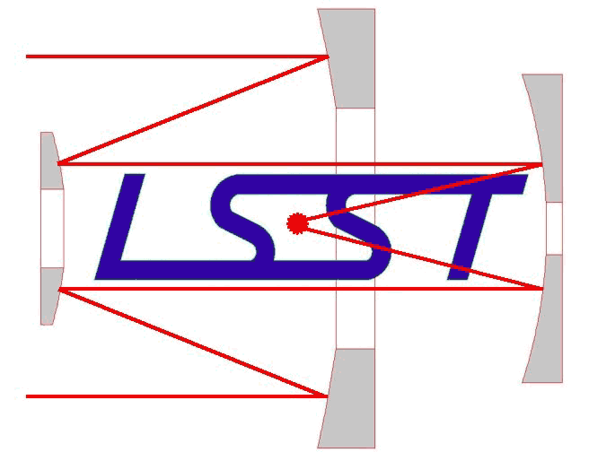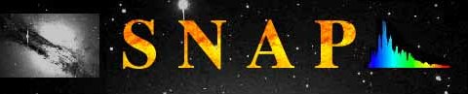UHawaii_ifa_headerucirvine_07_hor_289

Universities



National Research Laboratories

Industry

|  |
| --- |
|  |
| Communication |

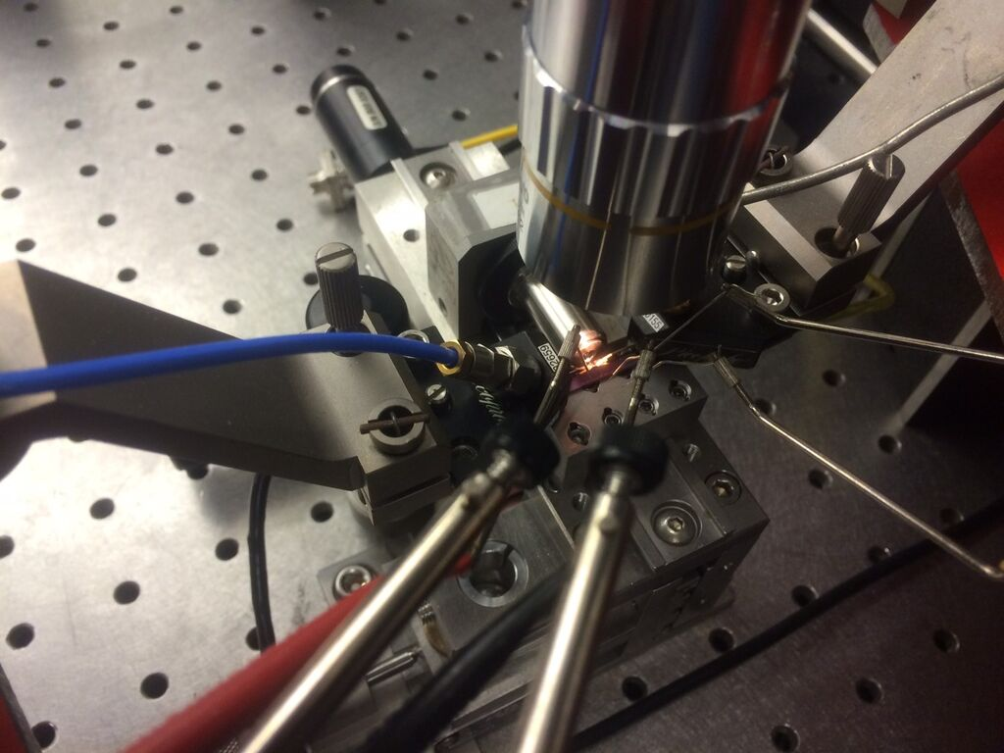

# In the News

## Future Photon Initiative Featured in RIT Research Magazine

Future Photon Initiative is a collaboration between current research centers at RIT to work together towards a common goal. There are four major groups coming together: Integrated Photonics Group, Microsystems Engineering Doctoral Program, Nanopower Research Laboratories, and Center for Detectors. RIT has awarded $1 million in funding to bring together these groups to merge into an internationally recognized Initiative. The FPI currently consists of 21 researchers and professors with a possibility of growing and in the near future. A part of the feature article is available below.

Future Photon Initiative  
Developing Advanced Photonics

By Jane E. Sutter

**Solving Pressing Problems**

Photonics is the field of technology that uses photons to process information or energy. Around the RIT campus, significant photonics research already takes place. The Center for Detectors develops next-generation detectors in a facility that rivals that of major space agencies. The NanoPower Research Laboratory designs and fabricates advanced photovoltaic devices. The Integrated Photonics Group is leading the design, fabrication, and characterization of photonic chips. And that’s but three examples.

The Future Photon Initiative (FPI) will leverage RIT’s unique assets to develop advanced photonics, which represents the cutting edge of the field of photonics, with the ultimate goal of becoming one of the most effective applied photon research and development centers in the world. Don Figer, director of the Center for Detectors, will lead the Initiative. “We’ve always had the idea to bring together the researchers to address the bigger problems” the world faces related to U.S. competitiveness and national security, he said. Initially, FPI will develop devices for advanced manufacturing, communications and information technology, defense and national security, energy, and health and medicine.

Some of those big questions Figer cites: “Are we alone in the universe? What is dark energy and dark matter?” and others listed at the beginning of this article. “The odd thing about these questions is they don’t seem to be related but they all overlap in the technology that’s needed to address them,” according to Figer.

FPI will apply and commercialize the efforts of existing RIT groups that develop technology for the generation, transmission, manipulation, absorption, and detection of photons.

Read on about the different research areas and the faculty that are involved at: <http://ridl.cfd.rit.edu/products/press/P1897%20Research%20FPI.pdf> See Figure 24 for the newly designed logo.

|  |
| --- |
|  |
| C:\Users\hw6083\AppData\Local\Microsoft\Windows\Temporary Internet Files\Content.Word\fpilogo.jpg |
| Figure . The logo of FPI was developed by the Vignelli Center at RIT along with brand applications. |
|  |

## Technology for Starshot Program could be developed in Rochester

Center for Detectors could be involved in a program that will send a satellite further than we have ever sent before. The Starshot program involves sending a probe to the nearest star several light years away to send back pictures and other data. The probe will need sophisticated camera components within the capabilities of Center for Detectors. Read on for details of the mission and how CfD can help.

**Technology for Starshot program could be developed in Rochester**

**Stephen Hawking's plan to reach Alpha Centauri will require photonics**

By JEFF RUSACK

Published 04/13 2016

ROCHESTER, N.Y. (WROC-TV)

Space. The final frontier.

But as we've seen over the last 55 years, since man first left our planet, we keep venturing farther and farther past those frontiers.

On Tuesday, scientists and investors announced a project to reach even farther, to Alpha Centauri, the star closest to earth. Although in this case, “close” is 4.37 light years away.

The project, called Starshot, is not an easy one. But the technology required to make it work could be developed here in Rochester.

Starshot, as explained by backer Stephen Hawking, would send a number of small probes the size of a cell phone into space on the back of a huge solar sail. The sail would be pushed by photonic lasers from earth to the nearest star (See Figure 25).

Starshot may sound crazy, but any plan that has Stephen Hawking on its side has to carry a lot of weight. Right now, though, technology has to catch up to the idea.

Some of those catch ups could happen right here in Rochester. Photonics require optics. And when it comes to moving objects with a beam of light, Optimax is already working technology that could be useful for the Starshot project.

Over at RIT, there may be a handful of discoveries that would help propel the Starshot program. The Director of the Center for Detectors at RIT says that the Institute has the resources to make key camera components for Starshot.

RIT has already reached out to Starshot scientists to see how they can help.

Starshot may be a long shot. It's planned to launch in roughly 20 years, and take another 20 to reach its target.

But if successful, mankind's greatest feat could have Rochester's fingerprints all over it.

|  |
| --- |
|  |
| C:\Users\hw6083\Desktop\breakthrough-starshot-nanocraft.jpg |
| Figure : A possible model of the Starshot Nanocraft that plans to launch in 20 years. Credit: Breakthrough Prize Foundation (via Livestream) |
|  |

To watch Don Figer’s interview and a visual representation of the Starshot program, go to <http://www.rochesterfirst.com/news/local-news/technology-for-starshot-program-could-be-developed-in-rochester>.

## CfD Part of the Future Photon Initiative

Center for Detectors will be a part of Future Photon Initiative which will advance new photonics devices. FPI was established as a part of the RIT’s new strategic investment.

RIT announces strategic investments in four research areas

Multidisciplinary teams to focus on cybersecurity, health care technology, photonics and unmanned aerial vehicle imaging

Feb. 8, 2016   
by [Ellen](mailto:smguns@rit.edu) Rosen

To advance its focus on conducting internationally distinguished research, Rochester Institute of Technology has chosen four initiatives to receive strategic investments.

These strategic initiatives, chosen through a rigorous internal process that looked at 26 research proposals, will each receive up to $1 million, payable over five years, on the condition that the projects meet their annual review goals. The projects will also receive funding through matching commitments made by deans, department heads, center directors and team members.

“The response from the RIT community to our call for research proposals was tremendous,” said Ryne Raffaelle, vice president for research and associate provost. “We received proposals from interdisciplinary teams that literally represented every college and institute on campus. The quality of the proposals was outstanding and necessitated a thorough, multi-stage process that involved both internal and external reviews by a variety of impartial stakeholders to identify the most meritorious proposals.”

Read on at <http://www.rit.edu/news/story.php?id=54566> to find out more about RIT’s new research centers.

## CfD Wins NSF Funding to Develop Next Generation Infrared Detectors

In September 2015, National Science Foundation awarded Center for Detectors funding to research and develop the next infrared Detectors. The new detectors will be more cost efficient further decreasing the cost for telescopes. CfD is partnering up with Raytheon Vision Systems for this project. You can read more about the benefits of this program below.

Next-generation Infrared detectors win NSF funding

Nov. 20, 2015   
by Susan Gawlowicz

Scientists at Rochester Institute of Technology and Raytheon Vision Systems are getting closer to developing infrared detectors grown on silicon wafers for ground-based astronomy. Other application areas—such as homeland security, remote sensing and biomedical imaging—could also benefit from the technology.

The National Science Foundation has awarded RIT nearly $2 million in second-phase funding for the [Center for Detectors](http://ridl.cfd.rit.edu/) to lead the development of this new family of detectors. The design, development and use of advanced astronomical instrumentation are part of the center’s strategic goals. A priority is also given to involving undergraduate and graduate students in the high-level research of advancing detector technology.

The sensitive detectors developed with Raytheon will have broad coverage from the optical to infrared wave lengths. They are designed to deliver the highest sensitivities available with today’s detectors but without the steep price tag of around $1 million per detector, said Donald Figer, director of RIT’s Center for Detectors and project leader.

“The proposed detectors will increase discovery space for today’s moderate-sized and large telescopes and future Extremely Large Telescopes, such as the Thirty Meter Telescope and the Giant Magellan Telescope,” Figer said.

The new design uses Raytheon’s advanced processing techniques for depositing a light sensitive layer of mercury, cadmium and telluride on silicon wafers. The material growth is done using molecular beam epitaxy, a technique common to the semiconductor industry. That technique combined with the availability of large silicon wafers could potentially reduce the cost and increase the size of these detector arrays, Figer said. Existing infrared detector technology depends on scarcely produced cadmium-zinc-telluride wafers. Cost constraints limit the availability and scale of these detectors.

The RIT-Raytheon team envisions a low-cost alternative that someday can be scaled up to 14,000 by 14,000 pixels. Their initial arrays will start with 1,024 by 1,024 pixels (see Figure 26) and ramp up to 4,096 by 4,096 pixels.

Figer previously designed a system for the Space Telescope Science Institute to test detectors to be flown on the future James Webb Space Telescope. His team will contribute to the design of the infrared detectors and measure their performance at RIT using a similar system.

|  |
| --- |
|  |
|  |
| Figure : One of the 1,024 by 1,024 detectors packaged in a carrier on a PCB with a flex cable that have been developed at Center for Detectors. |
|  |

## CfD Faculty Member Stefan Preble’s Work is featured on the Cover Article of the September Issue of Rochester Engineering Society Magazine

Professor Stefan Preble, director of the Nanophotonics group and faculty of the Microsystems Engineering Program wrote an article featured on the Cover of Rochester Engineering Society Magazine. The cover article explains the importance of integrated photonics in shaping our future. An excerpt of the article is featured below.

**The Next Revolution: Integrated Photonics**

***By Stefan Preble, Microsystems Engineering, Kate Gleason College of Engineering, RIT***

Integrated Photonics is the intersection of microelectronics and photonics. Microelectronics has been the driver of technology and the world’s economy for several decades. Its success is a direct result of the integrated circuit where billions of electrical components (transistors, wires, resistors, capacitors, etc.) are seamlessly integrated together on silicon wafers using manufacturing processes that have followed the scaling trends of Moore’s law. Photonic technologies are now at a point similar to where microelectronics was at in the early 1970’s - where just a relatively small number of components were tediously integrated together. However, by leveraging the manufacturing equipment and techniques that made microelectronics a success, it is now beginning to be possible to realize the same economies of scale to make integrated photonic circuits. Furthermore, since similar manufacturing technologies are being used, photonics and electronics can be directly integrated together to make both the electronic and photonic elements of the circuits function better - not only reducing size, weight and power but enabling entirely new applications, many of which have not been envisioned ( see Figure 27).

In order to understand integrated photonics a general overview of photonics is needed. Photonics is the study of the generation, manipulation and detection of light. Light is made up of photons, similar to how electric current is made up of individual electrons. However, photons have the distinct advantage that they travel at the speed of light and don’t consume any power during their propagation. For example, photons routinely travel across the entire universe (albeit after approximately thirteen-billion years) with just the energy required to initially produce them. Photons are also very efficient information carriers. They are an electromagnetic wave (just like a radio wave) that oscillates at very high frequencies, on the order of 200 THz (200 × 1012 Hz), and as a result can easily encode terabytes/second of information in their amplitude, phase and/or polarization.

There have been many platforms for photonics over the decades, such as fiber optics where discrete components (lasers, the actual fiber optic cable which transmits light, and detectors) are separately manufactured and put together. In the 1990’s the first steps towards integrated photonics were made with the development of planar lightwave circuits (PLCs), based on glasses that are patterned using photolithography or directly written by modifying the material using lasers. PLCs are still commonly used today and allow light to be guided and manipulated to interfere with itself, enabling switches and filters. However, the PLC platform illustrates the challenges of realizing truly integrated photonics. Specifically, the large size of the glass waveguides limits the ability to scale the circuit’s complexity (because of the limitations of total internal reflection) and more importantly, it is challenging to integrate the lasers and detectors on the same PLC chip because of the dissimilar material and manufacturing platforms.

|  |  |
| --- | --- |
|  | |
| ­ |  |
| Figure : (left) The images above show an integrated photonic chip connected to two optical fibers and (right) silicon photonics for quantum computing that are being developed for future application. | |
|  | |

To continue reading about the future of integrated photonics in our lives, please go to: <http://ridl.cfd.rit.edu/products/press/rochesterengineeringsociety/2015septembere-issuestefanpreble.pdf>

# Publications

* de la Fuente, D., Najarro, F., Borissova, J., Ramírez Alegría, S., Hanson, M. M., Trombley, C., Figer, D. F., Davies, B., Garcia, M., Kurtev, R., Urbaneja, M. A., Smith, L. C., Lucas, P. W., Herrero, A. 2016, *Probing the Dragonfish star-forming complex: the ionizing population of the young massive cluster Mercer 30*, Astronomy & Astrophysics, 589, A69
* Messineo, M., Menten, K., Figer, D., Ivanov, V., Zhu, Q., Kudritzki, R., Davies, Ben., Chen, R., Habing, H., Churchwell, E. 2016, *Hunting for massive late-type stars in the inner Disk of the Milky Way,* Cool Stars 19
* Kolb, K., Figer, D., Hanold, B., Lee, J. 2016, *Radiation tolerance of a Geiger-mode avalanche photodiode imaging array,* Journal of Astronomical Telescopes, Instruments, and Systems
* R. Liu, X. Zhao, C. Roberts, L. Yu, P. K. Mohseni, X. Li, V. Podolskiy, D. Wasserman 2016,*Enhanced Optical Transmission through MacEtch-Fabricated Buried Metal Gratings*, Advanced Materials 28, 1441-1448
* Messineo, M., Zhu, Q., Menten, K. M., Ivanov, V. D., Figer, D. F., Kudritzki, R. P., Chen, R. 2016, *Red supergiants in the inner galaxy: Stellar properties*, in preparation
* Messineo, M., Zhu, Q., Menten, K. M., Ivanov, V. D., Figer, D. F., Kudritzki, P. R., Chen, R. 2016, *Discovery of an extraordinary number of red supergiants in the inner galaxy*, The Astrophysical Journal, 822
* Zihao Wang, Ruizhe Yao, Stefan F. Preble, Chi-Sen Lee, Luke F. Lester, and Wei Guo 2015,*High performance InAs quantum dot lasers on silicon substrates by low temperature Pd-GaAs wafer bonding*, Applied Physics Letters 107, 261107
* Hanold, Brandon, Figer, Donald, Lee, Joong, Kolb, Kimberly, Marcuson, Iain, Corrales, Elizabeth, Getty, Johnathan, Mears, Lynn 2015, *Large format MBE HgCdTe on silicon detector development for astronomy*, SPIE Proceedings
* Messineo, M., Clark, J., Figer, D., Kudritzki, R. P., Najarro, F., Rich, R., Menten, K., Ivanov, V., Valenti, E., Trombley, C., Chen, C.-H., & Davies, B. 2015, *Massive stars in the W33 giant molecular complex,* The Astrophysical Journal, 805,

|  |
| --- |
|  |
| Organization |

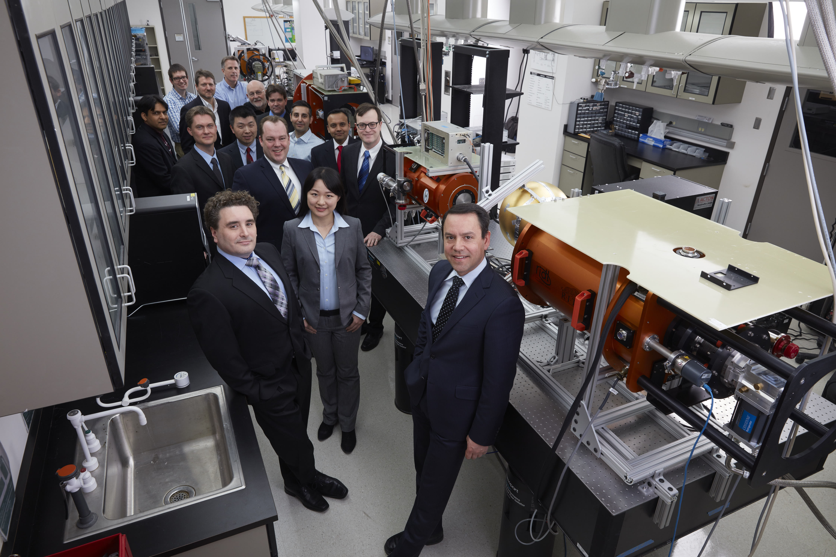

# Personnel

|  |  |  |  |  |  |
| --- | --- | --- | --- | --- | --- |
|  | |  | | | |
|  | | **Don Figer**  Director  Degree(s): PhD in Astronomy, 1995, UCLA; M.S. in Astronomy, 1992, U. Chicago; B.A. in Physics, Math, Astronomy, 1989, Northwestern U. | | | |
|  | |  | | | |
|  | |  | | | |
| http://ridl.cfd.rit.edu/images/personnel/zoran.jpg | | **Zoran Ninkov**  Professor  Degree(s): PhD, Astronomy, University of British Columbia, 1986; M.S.C., Physical Chemistry, Monash University, 1980; B.S.C. (1st class honors), Physics, University of Western Australia, 1977. | | | |
|  | |  | | | |
|  | |  | | | |
|  | | **Stefan Preble**  Professor  Degree(s): PhD, Electrical & Computer Engineering, 2007, Cornell University; B.S. in Electrical Engineering, 2002, Rochester Institute of Technology | | | |
|  | |  | | | |
|  | |  | | | |
|  | | **Jing Zhang**  Professor  Degree(s): PhD in Electrical and Computer Engineering, 2013, Lehigh University; B.S. in Electronic Science and Technology, 2009, Huazhong University of Science and Technology. | | | |
|  | |  | | | |
|  | |  | | | |
|  | | **Michael Zemcov**  Assistant Professor  Degree(s): PhD in Physics, Cardiff University, 2006, Cardiff, United Kingdom; B.S. in Physics, 2003, University of British Columbia, Canada | | | |
|  | |  | | | |
|  | |  | | | |
| [http://ridl.cfd.rit.edu/images/personnel/thumbnails/Parsian_Mohensi.jpg](http://ridl.cfd.rit.edu/images/personnel/Parsian_Mohensi.jpg) | | **Parsian K. Mohseni**  Assistant Professor  Degree(s): Ph.D. in Engineering Physics, 2011, McMaster University, Canada; B.Eng. in Engineering Physics, 2005, McMaster University, Canada | | | |
|  | |  | | | |
|  | |  | | | |
|  | | **Joong Lee**  Engineer  Degree(s): PhD in Physics, 2007, UCLA; B.S. in Physics, 1998, UC Berkeley | | | |
|  | |  | | | |
|  |  | | | | |
|  | **Brandon Hanold**  Engineer  Degree(s): B.S. in Astrophysics, 2006, Michigan State University | | | | |
|  |  | | | | |
|  | | |  | | |
|  | | | **Melissa McNulty**  Executive Assistant  Degree(s): B.S. in Chemical Engineering, May 2017, Rochester Institute of Technology | | |
|  | | |  | | |
|  |  | | | | |
|  | **Analia Briceno**  Executive Assistant  Degree(s): B.S. in Industrial Design, May 2018, Rochester Institute of Technology | | | | |
|  |  | | | | |
|  |  | | | | |
|  | | **Hyun Won**  Executive Assistant  Degree(s): B.S. in International Business, May 2017, Rochester Institute of Technology | | | |
|  | |  | | | |
|  |  | | | | |
|  | **Philip Linden**  Lab Assistant  Degree(s): BS/ME Mechanical Engineering, May 2017, Rochester Institute of Technology | | | | |
|  |  | | | | |
|  |  | | | |
|  | **Poppy Immel**  Lab Assistant  Degree(s): B.S./M.S. in Computational Mathematics and Computer Science, May 2017, Rochester Institute of Technology | | | |
|  |  | | | |
|  |  | | | | |
|  | **Kevin Kruse**  Lab Assistant  Degree(s): B.S./M.S. Electrical Engineering, May 2017, Rochester Institute of Technology | | | | |
|  |  | | | | |
|  | |  | | | |
|  | | **Sourabh Kulhare**  Software Developer  Degree(s): M.S. Computer Engineering, December 2016, Rochester Institute of Technology | | | |
|  | |  | | | |
|  | |  | | | |
|  | | **Katherine Seery**  PhD Student  Degree(s): B.A. in Physics and mathematics, May 2014, Alfred University | | | |
|  | |  | | | |
|  | | | |  | |
|  | | | | **Kevan Donlon**  PhD Student  Degree(s): PhD in Imaging Science, May 2018, Rochester Institute of Technology; B.S. in Physics, 2012, Rensselaer Polytechnic Institute | |
|  | | | |  | |

|  |  |  |
| --- | --- | --- |
|  |  | |
|  | **Yukee Ooi**  PhD Student  Degree(s): PhD in Microsystems Engineering, August 2018, Rochester Institute of Technology; BEng in Computer Engineering, May 2011, Hong Kong University of Science and Technology | |
|  |  | |
|  |  | |
|  | **Cheng Liu**  PhD Student  Degree(s): PhD in Microsystems Engineering, August 2019, Rochester Institute of Technology; B.S. in Physics, June 2013, Wuhan University, China | |
|  |  | |
|  | |  | |
|  | | **Zihao Wang**  PhD Student  Degree(s): B.S. in Opto-electronics, Huazhong University of Science and Technology | |
|  | |  | |
|  | |  | |
|  | | Chi Nguyen  PhD Student  Degree(s): PhD in Astrophysical Sciences and Technology; B.S. in Astronomy, 2015, University of Arizona | |
|  | |  | |
|  | |  | |
|  | | **Jeffrey Steidle**  PhD Student  Degree(s): PhD in Microsystems Engineering; B.S. in Physics, 2014, State University of New York at Geneseo | |
|  | |  | |
|  | |  | |
|  | | **Michael Fanto**  PhD Student  Degree(s): PhD in Microsystems Engineering; B.S. in Physics, 2002, Utica College of Syracuse University | |
|  | |  | |
|  | |  | |
|  | | **Dmitry Vorobiev**  PhD Student  Degree(s): PhD in Astrophysical Sciences and Technology; B.S. in Astrophysics, University of New Mexico. | |
|  | |  | |
|  | |  | |
|  | | **Ryan Scott**  Capstone Student  Degree(s): B.S. in Physics, May 2016, Rochester Institute of Technology | |
|  | |  | |
|  | |  | |
|  | | **Michael Potter**  Student Researcher  Degree(s): M.S. in Computer Science, August 2016, Rochester Institute of Technology; B.S. Computational Mathematics, May 2016, Rochester Institute of Technology; B.S. Biomedical Engineering, May 2016, Rochester Institute of Technology | |
|  | |  | |
|  | |  | |
|  | | **Emily Holz**  Student Researcher  Degree(s): B.S. Biomedical Engineering, May 2016, Rochester Institute of Technology | |
|  | |  | |

|  |  |  |
| --- | --- | --- |
|  | |  |
|  | | **Kyle Hunkar**  Student Researcher  Degree(s): B.S. Electrical Engineering, May 2016, Rochester Institute of Technology |
|  | |  |
|  | |  |
|  | | **Aravind Warrier**  Student Software Developer  Degree(s): B.S. Computer Science and Engineering, May 2012, College of Engineering in Trivandrum |
|  | |  |
|  | |  |
|  | | **Gilford Fernandes**  Student Software Developer  Degree(s): B.S. Electronics and Telecommunication, May 2013, Goa University |
|  | |  |
|  | |  |
|  | | **Jason Patel**  Student Researcher  Degree(s): B.S. Electrical Engineering, May 2017, Rochester Institute of Technology |
|  | |  |
|  | |  |
|  | | **Lindsay Demblowski**  Student Researcher  Degree(s): B.S. Biomedical Engineering, May 2016, Rochester Institute of Technology |
|  | |  |
|  | |  |
|  | | **Jetta Rackleff**  Executive Assistant  Degree(s): B.S. Chemical Engineering, May 2017, Rochester Institute of Technology |
|  | |  |
|  |  | |
|  | **Ariel Reid**  Executive Assistant  Degree(s): B.S. Mechanical Engineering Technology, December 2017, Rochester Institute of Technology | |
|  |  | |

# Charter

## About the Center for Detectors

The CfD designs, develops, and implements new advanced sensor technologies through collaboration with academic researchers, industry engineers, government scientists, and students. The CfD enables scientific discovery, national security, better living, and commercial innovation through the design and development of advanced photon detectors and associated technology in a broad array of applications such as astrophysics, biomedical imaging, Earth system science, and inter-planetary travel.

## Vision and Mission

Our Vision is to be a global leader in realizing and deploying ideal detectors and associated systems. Our Mission is to enable scientific discovery, national security, better living, and commercial innovation through the design and development of advanced photon detectors and associated technology by leveraging collaborations with students, scientists, engineers, and business partners, at academic, industrial, and national research institutions.

## Goals

* Develop and implement detector technologies that enable breakthroughs in science, defense, and better living.
* Train the next generation of U.S. scientists and engineers in team-based, interdisciplinary, world-class research.
* Create opportunities for faculty, students, and international leaders to advance the field of detectors and its relevant application areas.
* Grow externally-supported research.
* Increase economic activity for local, regional, and national companies.

## Focus Areas

The Center seeks to apply its technologies to many different scientific areas including Astrophysics, Biomedical Imaging, Defense, Earth Systems Science, Energy, Homeland Security, and Quantum Information. These focus areas are mainly what brings together the great variety of individuals from diverse areas of expertise.

Astrophysics – A zero read noise detector will enable the discovery of Earth-like planets around nearby stars, life on other planets, the nature of dark energy and dark matter, and the origins of stars and galaxies.

Biomedical Imaging – The Biophotonic Experiment Sensor Testbed will enable safe detection and monitoring of breast cancer and cognitive functioning with unprecedented sensitivity.

Defense – Space-based cameras will be equipped with the most sensitive detectors that provide rapid delivery of the most sensitive information.

Earth Systems Science – The Center’s detectors will be exploited to address fundamental Earth system science questions, such as sensing of photosynthesis or the creation of atmospheric pollutants, detection of atmospheric or ocean temperature gradients, or the timely viewing of extreme events.

Energy – New high photon-efficiency solar cells will be developed to ensure sustainable energy generation for economic competitiveness and national security.

Homeland Security – Advanced imaging detectors will be able to reveal potential airborne biochemical hazards through high-resolution three-dimensional ranging, spectral discrimination, and motion pattern recognition.

Quantum Information – High-speed single photon receivers will be deployed to support future technologies in photonics, communication, quantum computing, and quantum cryptography.

## Governance

The Center is supervised and operated by its founding Director, Dr. Donald Figer. A committee of experts, from RIT and elsewhere, advise the Director to ensure successful definition and execution of the Center’s vision and goals. The committee meets once per year after the completion of the CfD Annual Report. Center members include academic researchers, industry engineers, government scientists, and university/college students.

## Funding

Since its inception in 2006, the Center for Detectors has received over $16 million in research funding. The largest contributions are from the Moore Foundation and NASA. The Moore Foundation granted $3.0 million to support the development of a zero noise detector, while NASA awarded over $6 million in research grants. In 2012, NSF also became a major sponsor with a research grant of $1.2 million for the development and testing of infrared detectors grown on silicon wafers. This year, the CfD received $2M from NSF for the further development and testing of infrared detectors grown on silicon wafers.

# Capabilities, Equipment, and Facilities

The Center for Detectors is located in the Engineering building (Building 17) at the Rochester Institute of Technology. It has 5,000 square feet of space for offices and labs, including offices for 17 people, and four research laboratories: the Rochester Imaging Detector Laboratory (see Figure 28), the laboratory for suborbital rocket missions, the Imaging LIDAR laboratory, and the Wafer Probe Station laboratory.

|  |
| --- |
|  |
|  |
| Figure . Above is the main CfD lab, the Rochester Imaging Detector Laboratory. |
|  |

These facilities include a permanent clean room, ESD stations, vacuum pumping systems, optical benches, flow tables, light sources, UV-IR monochromators, thermal control systems, cryogenic motion control systems, power supplies, general lab electronics, and data reduction computers and more. The equipment is capable of analyzing both analog and digital signals. Separate rooms in the CfD are devoted to electrical rework and laser experiments. In addition to these dedicated facilities, the CfD has access to facilities within the Semiconductor and Microsystems Fabrication Laboratory (SMFL) and other areas across the RIT campus.

The RIDL detector testing systems (Figure 30) use four cylindrical vacuum cryogenic dewars. Each individual system uses a cryo-cooler that has two cooling stages: one at ~60 K (10 W) and another at ~10 K (7 W). The cold temperatures yield lower detector dark current and read noise. The systems use Lakeshore Model 340 temperature controllers to sense temperatures at 10 locations within the dewars and control a heater in the detector thermal path. This thermal control system stabilizes the detector thermal block to 400 K RMS over timescales greater than 24 hours. The detector readout systems include an Astronomical Research Camera controller having 32 digitizing channels with 1 MHz readout speed and 16-bit readout capability, two Teledyne SIDECAR ASICs having 36 channels and readout speeds up to 5 MHz at 12-bits and 500 kHz at 16-bits, custom FPGA systems based on Altera and Xilinx parts, and a JMClarke Engineering controller with 16 readout channels and 16-bit readout designed specifically for Raytheon Vision System detectors. The electronics packages are shown in Figure 29.

|  |  |  |
| --- | --- | --- |
|  | | |
|  |  |  |
| Figure . The three electronics packages used to test detectors are shown here. Electronics from left to right: Astronomical Research Camera Controller; JMClarke Engineering, Teledyne SIDECAR ASIC. | | |
|  | | |

The controllers drive signals through cable harnesses that interface with Detector Customization Circuits (DCCs), which are designed in-house and consist of multi-layer cryogenic flex boards. The DCCs terminate in a single connecter, which then mates to the detector connector. Three-axis motorized stages provide automated lateral and piston target adjustment. Two of the dewars have a side-looking port that is useful for exposing detectors to high energy radiation beams. The lab also has two large integrating spheres that provide uniform and calibrated illumination from the ultraviolet to through the infrared, and they can be mounted to the dewars. The dewars are stationed on large optical tables that have vibration-isolation legs (Figure 30).

|  |  |  |
| --- | --- | --- |
|  | | |
| http://ridl.cis.rit.edu/images/dewar_full.JPG |  |  |
| Figure . Detectors are evaluated in four custom dewar test systems. The fourth dewar is a duplicate of the one picture on the left. | | |
|  | | |

The lab equipment also includes a Pico Quant laser for LIDAR system characterization and other testing that requires pulsed illumination. In addition, the lab has monochromators with light sources that are able to produce light ranging from the UV into the IR, with an approximate wavelength range of 250 nm – 2500 nm. NIST-traceable calibrated photodiodes (with a wavelength range of 300 nm – 5000 nm) provide for absolute flux measurements. CfD also has a spot projector to characterize the inter-pixel response of the detectors, including optical and electrical crosstalk. Figure 31 shows a laser spot projection system on a 3D motorized stage that produces a small (~few microns) point source for measurements of intrapixel sensitivity.

|  |
| --- |
|  |
|  |
| Figure . Shown here is a laser spot projector with three axis motion control system. |
|  |

The lab contains eight data reduction computers, each with eight processors and up to 16 GB of memory for data acquisition, reduction, analysis and simulations, and 25 TB of data storage. Custom software runs an automated detector test suite of experiments. The test suite accommodates a wide variety of testing parameters through the use of parameter files. A complete test suite takes a few weeks to execute and produces ~0.5 TB of data. The data reduction computers reduce and analyze the data using custom automated code, producing publication-quality plots in near-real time as the data are taken.

In addition to the RIDL, CfD conducts research using The Lobozzo Photonics and Optical Characterization lab (Figure 32). Home to the Nanophotonics Group within the CfD and Led by CfD professor Dr. Stefan Preble. This group develops high performance nanophotonic devices and systems using Complementary metal–oxide–semiconductor compatible materials and processes. Their work will enable unprecedented performance and efficiency by leveraging the inherently high bandwidths and low power of photons with the intelligence of electronics. The group aims to demonstrate optoelectronic chips that will revolutionize future computing, communication and sensing systems.

The lab includes a Ti: Sapphire Laser, Optical Parametric Oscillator, Atomic Force Microscope, Ion Mill, Cryogenic Optoelectronic Probe Station, and Telecom test equipment. The lab is also used by other CfD, Microsystems Engineering faculty and students for various experiments, such as, Terahertz measurements and Time-Resolved Photoluminescence.

|  |  |  |
| --- | --- | --- |
|  | | |
|  |  |  |
| Figure . Shown here are Images of the Nanophotonics lab and Professor Stefan Preble working with graduate students. | | |

CfD collaborates with groups using the SMFL a 10,000 ft2 of cleanroom space in class 1000, 100, and 10. Using the SMFL’s resources, the Center can fabricate detectors with custom process flows, and has the freedom to use multiple process variations.

The Center’s flow-bench and probe stations offer wafer-level testing, even during the fabrication process, allowing mid-process design changes (Figure 33). The probe station accommodates electrical and circuit analysis of both wafers and packaged parts, including low current and radio frequency (RF) probing.

|  |
| --- |
|  |
|  |
| Figure . Device wafers are tested in the flow-bench lab probe station. |

The Amray 1830 Scanning Electron Microscope (SEM; see Figure 34), at the SMFL is used for high-magnification imaging of devices, and the WYKO white light interferometer, used for surface topography measurements. The SMFL also has other in-line fabrication metrology capabilities, including material layer thickness, refractive index, and wafer stress characterization tools.

|  |  |
| --- | --- |
|  | |
|  | \\Hawk\ridl\internal\projects\APRA\2006\internal docs\LOR Process Development\SEM Images\images\170c___265s___t.jpg |
| Figure . (left) The Amray 1830 Scanning Electron Microscope is used to image devices. On the right, a SEM image of a device that has been prepared for indium bump deposition. | |
|  | |

Figure 35 shows a customized setup consisting of two voltage power supplies, an Agilent oscilloscope, an LCD screen for viewing devices through the microscope probe station, and a custom circuit board for specific device diagnostics. The dedicated lab computer also runs a specially-designed data acquisition program to collect and analyze data from the device.

|  |
| --- |
|  |
|  |
| Figure . PhD student Kimberly Kolb conducts electrical experiments on one  of the cutting edge devices being characterized at the Center for Detectors. |
|  |

The entire probe station is covered so that no stray light enters the testing environment. These conditions provide the basis for valuable testing and data analysis. The probe tip is contacting a single test device via a metal pad with dimensions of only 70 microns by 70 microns (an area of 0.005 mm2), seen in Figure 36.

|  |
| --- |
|  |
|  |
| Figure . This image is a close-up of a device wafer being tested on the probe station. |
|  |

In addition to fabrication and testing capabilities, the Center for Detectors has access to sophisticated simulation software to predict the performance of devices, from fabrication processes to performance of a completed device. Silvaco Athena and Atlas are powerful software engines that simulate the effects of processing on device substrates and the electrical characteristics of a fabricated device. Athena simulations can describe all of the processes available in the RIT SMFL, building a physics-based model in 3D space of a device from initial substrate to completed device.

The Center for Detectors uses many other RIT facilities, *e.g.*, the Brinkman Lab, a state-of-the-art facility for precision machining, and the Center for Electronics Manufacturing and Assembly (CEMA), a facility for electronics packaging (Figure 37).

|  |
| --- |
|  |
|  |
| Figure . This image shows a cryogenic multi-layer circuit board designed in the CfD and populated in CEMA. All of the components on this board will be exposed to temperatures as low as 40 K, nanoTorr pressure levels, and high energy particle radiation. |
|  |

One of the newest additions to the Center’s facilities is the new suborbital rocket laboratory directed by Michael Zemcov. This 375 ${ft}^{2}$ lab is capable of creating technologies for experimental cosmology. The lab has equipment to assist in creating physical components and complementary software, seen in Figure 38. The laboratory contains an Oerlikon Leybold Turbolab turbo-molecular pump system, optical benches, lifting equipment, and tooling and component fabrication equipment. There are multiple computers capable of running sophisticated algorithms for astrophysics simulations. The lab also includes a millimeter wave spectrometric readout system for transition edge superconducting bolometers. There are plans to expand the lab’s capabilities in the future.

|  |  |
| --- | --- |
|  | |
| \\Hawk\ridl\internal\admin\oversight\annual reports\Annual Report 2016\images\Mike lab\DSC_0161.JPG | \\Hawk\ridl\internal\admin\oversight\annual reports\Annual Report 2016\images\Mike lab\DSC_0159.JPG |
| Figure . (left) A team of undergraduate students are using function generators, oscilloscopes, and FPGA based control boards to develop an image sensor reaout package that will fly on a suborbital platform. (right) A new Oerlikon Leybold Turbolab turbo-molecular pumping station was procurred during the past year. | |
|  | |