Dissertation Proposal Document

- Technology Introduction
CMOS single-photon counting detectors count single photons. They are able to do this because of their design. They are becoming increasingly relevant in astronomy. I am interested in astronomy.
- Completed Work
This section describes the HWK4123 characterization program, including the hardware, software, and data analysis.
  - Dark Current
We have measured the dark current of the HWK4123 at different temperatures. The dark current is low. However, we encounter a dark current plateau and we notice glow in the detector. We need to understand why these are happening.
  - Read Noise
We have measured the read noise of the HWK4123. The read noise is low.
  - Crosstalk
We have measured the crosstalk of the HWK4123. The crosstalk is low.
  - Conversion Gain and the Capacitance of the Floating Diffusion
We have measured the conversion gain of the HWK4123 for different programmable gain settings and the capacitance of the floating diffusion. They are appropriate for the sensor.
83–0.95 for CMOS detectors [1] [2].
  - Quantum Efficiency
We have measured the quantum efficiency of the sensor. We have not yet corrected for linearity or for quantum yield. We have a path forward to correct for linearity. We do not have a path forward for quantum yield but we are investigating it.

  - Persistence
We have measured persistence for the sensor. The persistence is low, but it is not corrected for linearity. The persistence itself may be an effect linked to linearity.
- Laboratory Measurements Results
  - Dark Current
The dark current measurements are shown in Figure 1. The left panel shows the median signal of pixels in the analysis region, represented by the black dots. The red line is a fit to the dark signal as a function of time, with a slope of 0.00054 e⁻/s/pixel. The right panel is a histogram of the DC evaluated for each pixel in the analysis region. The figure includes a cumulative curve that shows the histogram contains 99% (y-axis on the right) of all pixels within the analysis region. The red line is the mean value of a Gaussian fit to the distribution, giving a DC of 0.0005 e⁻/s/pixel at 202 K.
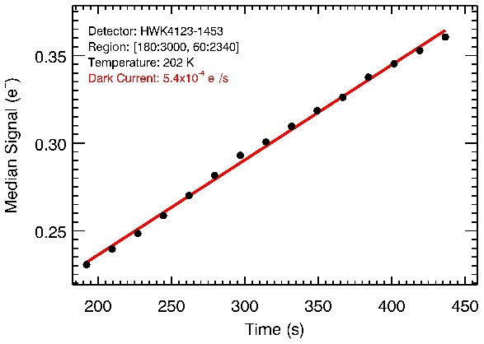 | 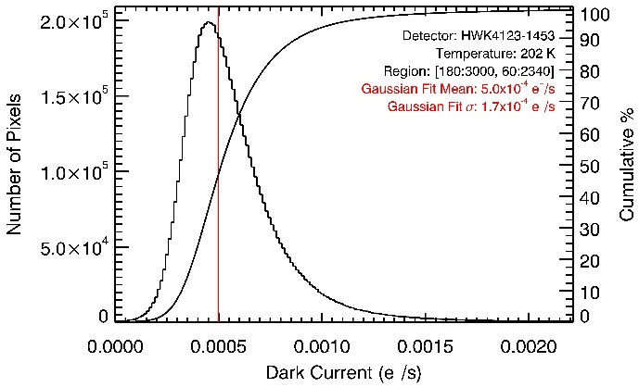
Figure 1. (left) The plot shows the median dark signal as a function of time at 202 K. The black points are the median dark signal of all pixels in the analysis region. The red line is a fit to the signal as a function of time. The slope of the red line is the DC of 0.00054 e⁻/s/pixel. (right) The plot shows the histogram of DC per pixel at 202 K. The y-axis on the left is the number of pixels per DC bin on the x-axis. The y-axis on the right is the cumulative percentage of pixels up to a DC bin. The vertical red line is the mean of a Gaussian fit to the distribution, which has a DC value of 0.0005 e⁻/s/pixel.
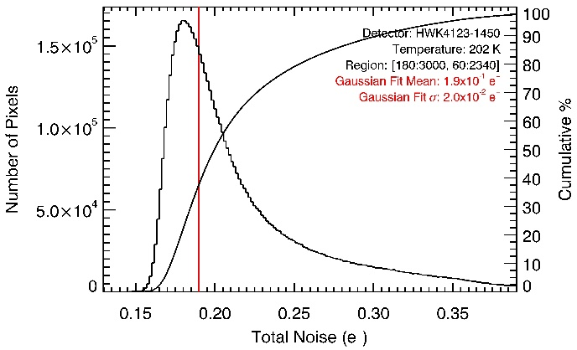
Figure 2. The plot shows the total noise histogram. The y-axis on the left is the number of pixels per total noise bin on the x-axis. The y-axis on the right is the cumulative percentage of pixels up to a total noise bin. The red line is the mean of a Gaussian fit to the distribution, which gives a read noise of 0.19 e⁻/pixel.
  - Read Noise
The total noise distribution is shown in Figure 2. Read noise dominates the total noise when the DC shot noise is negligible. The histogram in Figure 2 shows the RN distribution using the standard deviation of the signal in each pixel at a temperature of 202 K. The smooth black curve shows the cumulative percentage of pixels up to a given read noise bin. The red line is the mean value of a Gaussian fit to the distribution, giving an RN of 0.19 e⁻/pixel. The distribution has a hot tail typical of CMOS SPCDs [3] [4].
  - Conversion Gain and FD Capacitance
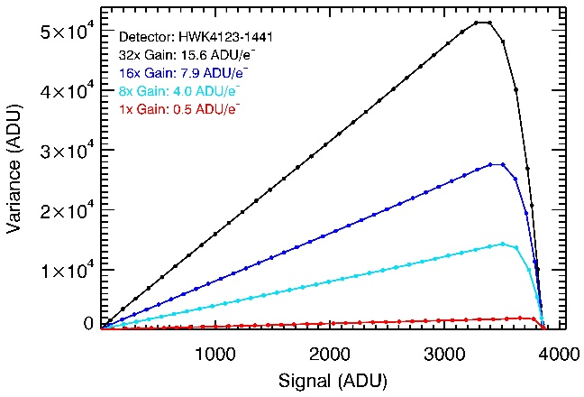
Figure 3. The plot shows PTCs for all programmable gains. The y-axis is the variance in signal in ADU. The x-axis is the signal in ADU. The inverse slope of the linear region is CG_{sys}.
We measure CG_{sys} using the PTE to get the inverse slope of a fit to the linear region of the PTC. Figure 3 shows PTCs for all programmable gains of the HWK4123. The black curve is 32× gain, the dark blue curve is 16× gain, the light blue curve is 8× gain, and the red curve is 1× gain. Each dot in the curves represents the median dark-subtracted signal for all pixels in the analysis region. The PTCs show that the detector output value reaches the maximum of the ADC sampling range (4,095 ADU), which is limited by the voltage swing at the FD and does not reach physical saturation [5]. Note that the x-axis in Figure 3 shows the dark-subtracted signals. We divide 4,095 ADU by CG_{sys} to obtain the number of electrons at the maximum output value, listed as N_{elec} in Table 1. The team is investigating methods to measure physical saturation at all gains by changing the voltage level at TG.
We then measure CG_{measured} and multiply by CG_{sys} to calculate CG_{FD} using Error! Reference source not found. and ε_{coupling} = 0.94. We derive CG_{elec} using Error! Reference source not found., CG_{measured}, ε_{coupling} = 0.94, and G_{SF} = 0.9. We calculate C_{FD} using Error! Reference source not found. and CG_{FD}. Table 1 compiles measurements of CG_{sys} and CG_{measured}, and derived values for CG_{elec}, CG_{FD}, C_{FD}, and N_{elec} for all programmable gains of the HWK4123.
 | CG_{sys} [ADU/e⁻] | CG_{measured} [μV/ADU] | CG_{elec}  [μV/ADU] | CG_{measured} ×CG_{sys}[μV/e⁻] | CG_{FD}  [μV/e⁻] | C_{FD}  [fF] | N_{elec}  [e⁻]
Gain: 32× | 15.6 | 11.6 | 9.8 | 181.2 | 170.3 | 0.94 | ~256
Gain: 16× | 7.9 | 22.8 | 19.3 | 180.5 | 169.7 | 0.94 | ~504
Gain: 8× | 4.0 | 45.6 | 38.6 | 180.6 | 169.8 | 0.94 | ~1,010
Gain: 1× | 0.5 | 361.1 | 305.5 | 180.6 | 169.8 | 0.94 | ~8,000
Table 1. This table lists measurements for CG_{sys} and CG_{measured}, and derived values for CG_{measured} × CG_{sys}, CG_{elec}, CG_{FD}, C_{FD}, and N_{elec}, for all programmable gains of the HWK4123.
  - Quantum Efficiency
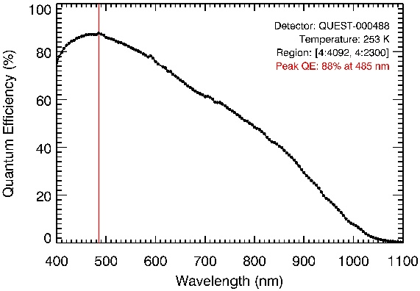
Figure 4. The curve shows the HWK4123 QE measured at 253 K with the QUEST system. The red line marks the peak QE of 88% at 485 nm.
The QE shown in Figure 4 is measured with the QUEST system. The peak QE is 88% at 485 nm as shown by the red line. In addition, QE is above 80% from 410 nm to 570 nm. The central wavelengths of the measurements have a spacing of 5 nm. Each black dot in Figure 4 represents the median value of the QE of all pixels in the analysis region, at 253 K. At wavelengths shorter than 400 nm, the probability of producing more than one electron increases (QY greater than unity). The team is actively investigating QY corrections to QE below 400 nm by following the work of [6].
  - Crosstalk
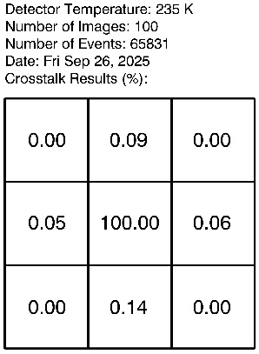
Figure 5. The panel shows the crosstalk for the HWK4123.
We measure crosstalk using the ratio of the signal in pixels surrounding a central pixel affected by an HEE. Figure 5 shows the mean value of these ratios for ~66,000 events, with the central pixel normalized to 100%. Crosstalk is negligible for the HWK4123 when compared to dominant noise terms under assumed observing conditions (i.e., dark current, read noise, zodiacal and exozodiacal dust), and will not be a concern for a flagship mission such as HWO.
  - Persistence
We measure persistence as the residual signal in a pixel following a reset. We use a pulsed laser attached to the QUEST camera to illuminate the HWK4123 to an initial fluence of ~5100 e⁻, which is ~70% of the maximum signal measurable with the QUEST camera using dual-gain mode operation. After 0.5 s, only 0.02% of the initial signal remains (~1 e⁻) in the first dark frame after the pulse. This level of persistence is negligible, especially when considering that target slews in space observatories (such as HWO) provide ample time to continuously read out and clear the pixels, such that persistence will not limit observations.
- Simulated Observation of an Earth-like Exoplanet
This section describes a simulated observation of an Earth-like exoplanet orbiting a Sun-like star. We use the open-source code exoVista [7] to contextualize the HWK4123’s performance for HWO. ExoVista is a comprehensive exoplanetary system simulation tool that includes a default Solar System analogue with system inclination and contamination from zodiacal dust (ZD) and exozodiacal dust (XZD). We simulate an HWO-like observation for biosignatures in the reflected and emitted spectrum of an exoplanet atmosphere. We use the built-in parameters and spectra in this work, with data sources listed in Table 1 of [7].
We define astronomical signal sources as light from the exoplanet, host star, ZD, and XZD. ExoVista outputs the spectral flux in Janskys (Jy) for the star, ZD, and XZD, while it provides the contrast ratio spectrum for the exoplanet. We recover the exoplanet flux by multiplying its contrast ratio spectrum by the host star flux. The Solar System analogue is 10 pc away, and the telescope diameter is 6 m. We propagate the flux from astronomical sources (F) through LUVOIR’s ECLIPS-A instrument (see Figure 8-27 of [8]) in the absence of an HWO optical diagram. The end-to-end throughput (TP) is 26% with values described in Appendix A, which is similar to the 27% TP reported in Figure 3 of [9] for the same instrument. We convert the flux from Jy to a number of photons per second per wavelength using F, the telescope area (A_{T}), TP, the photon energy (hc/λ), and the frequency-to-wavelength conversion (c/λ²). We integrate to the number of photons per second per channel (S_{exoV}) using the exoVista data channel spacing (Δλ_{exoV}), with the general form shown in Eq. 1:
 | $S_{exoV}=F×A_{T}×TP×\frac{λ}{hc}×{Δλ}_{exoV}×\frac{c}{λ^{2}}×(1×{10}^{-23}erg/s/{cm}^{2}/Hz/Jy)$ | Eq. 1
Then, we rebin these channels to match the baselined ECLIPS-A spectral resolution (R=λ/Δλ=140) at visible wavelengths. We use weights (ω_{i}, from 0 to 1) to redistribute photons from exoVista channels into the ECLIPS-A channels since their boundaries do not align perfectly. The general form S of the rebinned channels is given in Eq. 2:
 | $$S(γ/s/channel)= \sum_{i=λ_{i,start}}^{λ_{i,end}}{\frac{ω_{i} × S_{i,exoV}}{{λ_{i}}/{140}}}$$ | Eq. 2
We calculate the signal-to-noise ratio (SNR) as a function of time when observing a target biosignature in the Earth’s spectrum. Table 2 describes the quantities used to calculate the SNR of the observed biosignature in Eq. 3. First, we multiply the signal of astronomical sources from Eq. 2 by the detector QE and time, and adopt the baselined HWO coronagraph contrast ratio of 10⁻¹⁰ to block the stellar light [10]. Then, we compute shot noise from astronomical sources and detector DC using Poisson statistics. The detector RN scales with the number of frames, and adds in quadrature with the shot noise contributions.
We determine the number of pixels per spectral channel (denoted p) by following the method described in [11]. Similar to LUVOIR, [11] assumes the integral field spectrograph lenslet array is Nyquist sampled at 500 nm, such that p = N_{lenslet} × N_{dispersed}, assuming N_{lenslet} = 4(λ_{char}/500 nm)² and N_{dispersed} = 6(140/R). We get p = 55 pixels for λ_{char} = 760 nm and R = 140.
We assume an integration time of 250 s per frame to limit the effects of cosmic rays to ~1% of the pixel array. HWO will orbit at the Sun-Earth Lagrange Point 2 (L2), where JWST measurements show a shielded cosmic ray event rate of ~2.3 ions/cm²/s near solar maximum [12]. A typical event affects 7.1 pixels in JWST’s 18 µm-pitch H2RG detectors, which scales by area to ~100 HWK4123 pixels. The HWK4123 has an active area of ~2 cm², implying ~1150 cosmic ray events in a 250 s exposure and contamination of ~1% of its 9.4 Mpixels. We calculate the number of frames (n) by dividing the total integration time (t) by 250 s, and use a step size of 250 s to avoid fractional frames.
Symbol | Quantity Description | Units | Notes
S_{P} | Signal from exoplanet | γ/s/channel | from Eq. 2
S_{ZD} | Signal from zodiacal dust | γ/s/channel | from Eq. 2
S_{XZD} | Signal from exozodiacal dust | γ/s/channel | from Eq. 2
S_{S} | Signal from host star | γ/s/channel | from Eq. 2
K_{CR} | Coronagraph contrast ratio | dimensionless | following [10]
QE | Detector quantum efficiency | e⁻/γ | from Section 3.4
DC | Detector dark current | e⁻/s/pixel | from Section 3.1
RN | Detector read noise | e⁻/pixel | from Section 3.2
p | Number of pixels | pixel | following [11]
n | Number of frames | dimensionless | n = t / 250 s
t | Total integration time | s | step size = 250 s
Table 2. This table lists the quantities used to determine SNR in Eq. 3.
We select the O₂-A band at 760 nm as the target biosignature in the Earth’s spectrum. Detecting the O₂-A band requires a spectral resolution of R~140 [13], which is assumed for Eq. 2. For Earth, the presence of the O₂-A band is due to a biological process: photosynthesis. As such, O₂ may reveal the presence of a biosphere in exoplanets, with a careful treatment of false positives [14] [15] [16] [17] [18].
 | $$SNR\left(t,n\right)= \frac{S_{P}⋅t ⋅QE}{\sqrt{({ (S}_{P}+S_{ZD}+S_{XZD}+S_{S}⋅K_{CR})⋅QE+DC)⋅t+{(RN⋅\sqrt{n})}^{2}} }$$ | Eq. 3

We present results for four cases that explore the parameter space of Eq. 3:
1) using only the signal from the planet (item 1 in Table 2),
2) using only the signal from astronomical sources (items 1–5 in Table 2),
3) using all parameters with the baseline HWO detector specifications (all of Table 2), and
4) using all parameters with the measured HWK4123 detector performance (all of Table 2).
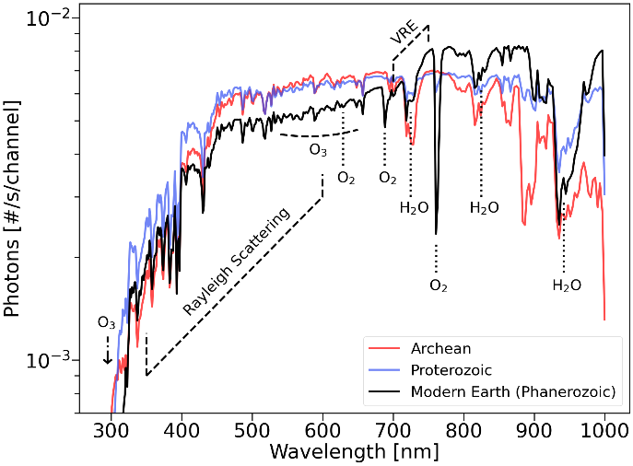
Figure 6. The plot shows integrated spectra of the Earth during different life-bearing eons. The y-axis is the number of photons per second per spectral channel (S), and the x-axis is the corresponding channel wavelength. The black curve corresponds to modern Earth and is labeled with biosignatures.
The exoplanet observation simulation results include the spectral photon flux and the SNR as a function of time when resolving the O₂-A band at 760 nm. Figure 6 shows the exoplanet flux per channel for different life-bearing eons of the Earth. The red curve represents the Earth’s atmosphere during the Archean eon, which was largely anoxic and likely methane-rich. The blue curve represents the Earth’s atmosphere for the Proterozoic eon, following the Great Oxygenation Event when atmospheric oxygen became detectable. The modern Earth spectrum (Phanerozoic) is shown in black and labeled with prominent biosignatures such as O₃, O₂, H₂O, and the vegetation red edge (VRE). The VRE is caused by land vegetation that absorbs visible light primarily through chlorophyll a and b, scatters light internally and externally due to the structure of leaves, and strongly reflects infrared light [19]. The O₂-A band in the modern Earth spectrum is a narrow and deep absorption line, with a full-width at half maximum of ~5 nm [20]. In this observation, only ~7 photons per hour reach the detector from the central part of the O₂-A band, while ~28 photons per hour arrive from the continuum, which gives the O₂-A band an equivalent width of ~1.25 nm.
The left panel of Figure 7 shows the SNR achieved (SNR_{achi}) for an O₂-A band observation as a function of time, for each case listed above. The black curve only considers signal from the planet, and the dark blue curve only considers signal from astronomical sources (planet, star, zodiacal and exozodiacal dust). Thus, the planet and astronomical curves assume perfectly noiseless detectors. The light blue curve uses all parameters in Eq. 3 with the baselined HWO detector performance, while the red curve uses the HWK4123 detector performance. Comparing the black and dark blue curves explains the need for a coronagraph to suppress starlight, since ZD and XZD contributions (along with leaking starlight) still significantly decrease SNR_{achi}. Comparing the dark and light blue curves explains HWO’s demanding detector performance specifications, which seek to minimize the degradation of SNR_{achi}. Finally, comparing the light blue and red curves proves that current state-of-the-art CMOS SPCDs require development, but also suggests that the measurements are reasonably possible with current technology. For 55 pixels, HWO reaches SNR=5 in 1.37 days, while the HWK4123 would require 10.1 days. Current CMOS SPCDs can detect the O₂-A band, but require more time per observation, which would reduce the total number of observations possible for a fixed mission lifetime.
The right panel of Figure 7 shows the amount of time needed to reach SNR=5 for the O₂-A band based on the number of pixels used per spectral channel (p). For instance, using 16 pixels for the 760 nm spectral channel leads to an integration time of 0.5 days for HWO and 1.5 days for the HWK4123 to reach SNR=5, highlighting the coupled impact of detector performance and optical design on the mission.
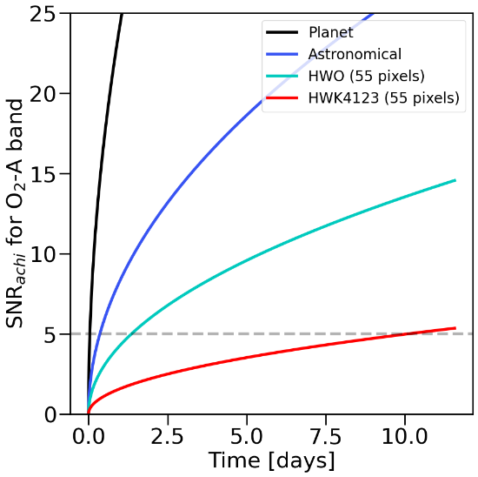 | 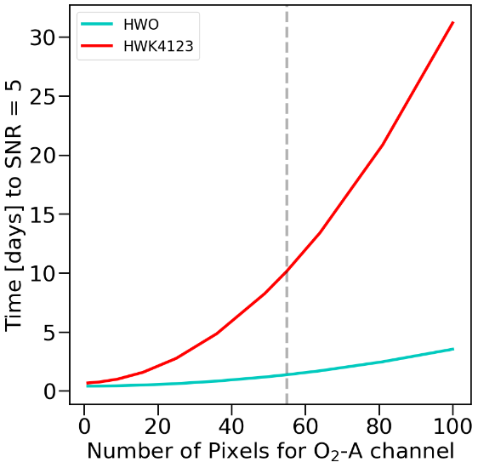
Figure 7. (left) The plot shows SNR as a function of time for different observing scenarios. (right) The plot shows the amount of time needed to reach SNR=5 for the O₂-A band based on the number of pixels used per spectral channel.
- Work that Remains
  - Understanding Low Signal Nonlinearity (LSNL)
While low signal nonlinearity is clearly observed, what is causing it? Is it canonical traps that are defects in the material? Is it unintended secondary potential wells that form during charge transfer, during transfer gate operation, or some other time? Where is this effect located, and can we figure that out? Is the effect dependent on temperature, wavelength, or programmable gain setting? How can we tell this apart from quantum efficiency and quantum yield, since these quantities also effect the translation from “number of photons that arrive at the sensor” to “number of electrons reported in the FITS file?”
  - Understanding the Dark Current Plateau and Glow (Multiplexer and Unit Cell)
Not much is known about the dark current plateau for silicon sensors. Are we hitting a physical limit of the material? Is the system in which the sensor finds itself too bright in the optical? Is the multiplexer glow enough to cause the dark current plateau for the entire sensor? Can there be unit cell glow at play? Under what circumstances would MOSFETs used in SPSCMOS emit light? Do we meet these conditions? Can we break the dark current plateau, since the lowest dark current we can measure is only as low as the system is dark?
  - Leveraging Single-Photon Counting to Introduce Rounding Step Using Bit Error Rate to Improve SNR
Because we have single-photon counting detectors, the device will report a floating point number of electrons. However, because the read noise is low, the bit error rate is also low. As such, we can assign the floating point number of electrons with a degree of certainty (the bit error rate) to integer electron numbers. In doing so, the uncertainty associated with the measurement is no longer the analog read noise, but it is the error of a Bernoulli trial: either we assigned the correct integer number of electrons, or we did not, and the “likelihood of failure” is equal to the bit error rate. As such, we are developing and investigating the validity of this processing method of information, which may provide a software boost to a technological limit and circumvent the need for R&D by using intelligent signal processing.

- Conclusion
The Habitable Worlds Observatory will need improved detector technology to achieve its science goals. CMOS SPCDs satisfy some of the detector specifications for read noise, dark current, and quantum efficiency. Specifically, the HWK4123 is a photon-number-resolving detector with a dark current of 0.0005 e⁻/s/pixel, a read noise of 0.19 e⁻/pixel, a quantum efficiency above 80%, and negligible persistence and crosstalk. These results indicate that CMOS SPCDs represent a credible and technologically mature pathway toward development for HWO. Part of that development includes the completion of our ongoing on-sky testing program at a telescope, and radiation testing for an equivalent irradiation dose at L2, where HWO would orbit. As such, the continued development of CMOS SPCDs offers a clear path to reducing detector risk for future HWO instruments.

APPENDIX A
The Habitable Worlds Observatory will have a coronagraph and spectrograph instrument for exoplanet direct imaging and spectral analysis. To simulate an exoplanet observation with HWO, we estimate the end-to-end throughput of the system using the LUVOIR ECLIPS-A design. Table 3 lists the LUVOIR ECLIPS-A optical components and their assumed efficiencies at 760 nm.
Component | Material | Type | Efficiency
Primary Mirror | Al + eLIF + MgF₂ [21] | Reflective - Powered Optic | 0.88
Secondary Mirror | Al + eLIF + MgF₂ | Reflective - Powered Optic | 0.88
Tertiary Mirror | Al + eLIF + MgF₂ | Reflective - Powered Optic | 0.88
Fast Steering Mirror | Al + eLIF + MgF₂ | Reflective - Flat Optic | 0.88
Pupil Relay 1 | Al + MgF₂ [21] | Reflective - Powered Optic | 0.88
Pupil Relay 2 | Al + MgF₂ | Reflective - Powered Optic | 0.88
Fold Mirror 1 | Al + MgF₂ | Reflective - Flat Optic | 0.88
UV/Vis Dichroic | using Thorlabs DMLP425T [22] | Dichroic (trans.) - Flat Optic | 0.97
Vis/NIR Dichroic | using Thorlabs DMLP900T [23] | Dichroic (refl.) - Flat Optic | 0.99
Deformable Mirror 1 | Ag [24] | Reflective - Flat Optic | 0.99
Deformable Mirror 2 | Ag | Reflective - Flat Optic | 0.99
Off-Axis Parabola 1 | Ag | Reflective - Powered Optic | 0.99
Fold Mirror 2 | Ag | Reflective - Flat Optic | 0.99
Off-Axis Parabola 2 | Ag | Reflective - Powered Optic | 0.99
Apodizing Mask | Ag | Reflective - Flat Optic | 0.99
Off-Axis Parabola 3 | Ag | Reflective - Powered Optic | 0.99
Focal Plane Mask | using [25] | Transmissive - Flat Optic | (0.995)²
Off-Axis Parabola 4 | Ag | Reflective - Powered Optic | 0.99
Lyot Stop | using [26] | Transmissive - Flat Optic | 0.9
Spectral Filter | using BBAR BARC-11 [27] | Transmissive - Flat Optic | (0.995)²
Relay Mirror 1 | Ag | Reflective - Powered Optic | 0.99
Relay Mirror 2 | Ag | Reflective - Powered Optic | 0.99
Lenslet & Pinhole Array | using [28] | Transmissive - Flat Optic | 0.95 × 0.975
Field Lens | using BBAR BARC-11 | Transmissive - Powered Optic | (0.995)²
Collimating Triplet (1) | using BBAR BARC-11 | Transmissive - Powered Optic | (0.995)²
Collimating Triplet (2) | using BBAR BARC-11 | Transmissive - Powered Optic | (0.995)²
Collimating Triplet (3) | using BBAR BARC-11 | Transmissive - Powered Optic | (0.995)²
Dispersing Prisms (1) | using BBAR BARC-11 | Transmissive - Flat Optic | (0.995)²
Dispersing Prisms (2) | using BBAR BARC-11 | Transmissive - Flat Optic | (0.995)²
Dispersing Prisms (3) | using BBAR BARC-11 | Transmissive - Flat Optic | (0.995)²
Imaging Triplet (1) | using BBAR BARC-11 | Transmissive - Powered Optic | (0.995)²
Imaging Triplet (2) | using BBAR BARC-11 | Transmissive - Powered Optic | (0.995)²
Imaging Triplet (3) | using BBAR BARC-11 | Transmissive - Powered Optic | (0.995)²
Fold Mirror 4 | Ag | Reflective - Flat Optic | 0.99
Throughput |  |  | 0.26
Table 3. This table lists LUVOIR ECLIPS-A instrument components for the visible band optical path (see Figure 8-27 of [8]) and their material efficiencies. Note that materials marked as “using” were not specified by [8].

Disclosures
The authors declare that there are no financial interests, commercial affiliations, or other potential conflicts of interest that could have influenced the objectivity of this research or the writing of this paper.

Code and Data Availability
Data reported in this paper will be free for reuse. The Flexible Image Transport System (FITS) data contain significant intellectual property and will only be shared in response to requests that do not jeopardize confidentiality.

Acknowledgments
The results presented in this paper are supported by the NASA Strategic Astrophysics Technology (SAT) Program (Grant No. 80NSSC20K0310). The large language model ChatGPT was used for language and grammar clean-up.

References

[1] | S. Xie and A. Theuwissen, "Compensation for Process and Temperature Dependency in a CMOS Image Sensor," Sensors, vol. 19, no. 4, 2019.
[2] | Y. Chen, A. J. Mierop and A. J. P. Theuwissen, "A CMOS Image Sensor With In-Pixel Buried-Channel Source Follower and Optimized Row Selector," IEEE Transactions on Electron Devices, vol. 56, no. 11, pp. 2390-2397, 2009.
[3] | J. Gallagher, L. Buntic, E. Alexani, K. Bouthsarath and D. Figer, "Characterizing radiation-tolerant single photon resolving CMOS detectors," Proceedings of the SPIE, vol. 13103, 2024.
[4] | J. P. Gallagher, L. Buntic, W. Deng and D. F. Figer, "Characterization of single-photon sensing and photon-number resolving CMOS image sensors," SPIE Astronomical Telescopes + Instrumentation, vol. 12191, 2022.
[5] | K. Cho and B. Johnson, "0.5e- rms Read Noise CMOS Image Sensors and Sub-Electron Image Processing for Night Vision Application," International Image Sensor Workshop, 2023.
[6] | S. Baggett, "WFC3 TV3 Testing: Quantum Yield in the UV," WFC3 Instrument Science Report, 2008.
[7] | C. C. Stark, "ExoVista: A Suite of Planetary System Models for Exoplanet Studies," The Astronomical Journal, vol. 163, no. 3, p. 11, 2022.
[8] | "LUVOIR Final Report," 26 August 2019. [Online]. Available: https://asd.gsfc.nasa.gov/luvoir/reports/LUVOIR_FinalReport_2019-08-26.pdf.
[9] | L. Pueyo, C. Stark, R. Juanola-Parramon, N. Zimmerman, M. Bolcar, A. Roberge, G. Arney, G. Ruane, A. J. Riggs, R. Belikov, D. Sirbu, D. Redding, R. Soummer, I. Laginja and S. Will, "The LUVOIR Extreme Coronagraph for Living Planetary Systems (ECLIPS) I: searching and characterizing exoplanetary gems," in Proceedings of SPIE, 2019, 2019.
[10] | M. R. Bolcar, F. Zhao and P. Scowen, "Habitable Worlds Observatory Technology Roadmap," 14 11 2024. [Online]. Available: https://ntrs.nasa.gov/api/citations/20240014305/downloads/Bolcar_MirrorTechDays_HWOTech_20241118_v3.pdf.
[11] | C. C. Stark, N. Latouf, A. M. Mandell and A. Young, "Optimized bandpasses for the Habitable Worlds Observatory’s exoEarth survey," Journal of Astronomical Telescopes, Instruments, and Systems, vol. 10, no. 1, 2024.
[12] | B. J. Rauscher and D. Fixsen, "JWST NIRSpec's Cosmic Ray Experience at L2," Publications of the Astronomical Society of the Pacific, vol. 137, no. 9, p. 095003, 2025.
[13] | T. D. Brandt and D. S. Spiegel, "Prospects for Detecting Oxygen, Water, and Chlorophyll on an Exo-Earth," PNAS, vol. 111, p. 11, 2014.
[14] | M. Damiano and R. Hu, "Reflected Spectroscopy of small exoplanets II: characterization of terrestrial exoplanets," The Astronomical Journal, vol. 163, p. 14, 2022.
[15] | S. Seager and D. Deming, "Exoplanet Atmospheres," Annual Review of Astronomy and Astrophysics, vol. 48, pp. 631-672, 2010.
[16] | E. Schwieterman, N. Kiang, M. Parenteau, C. Harman, S. DasSarma, T. Fisher, G. Arney, H. Hartnett, C. Reinhard, S. Olson, V. Meadows, C. Cockell, S. Walker, J. Grenfell, S. Hedge, S. Rugheimer, R. Hu and T. Lyons, "Exoplanet Biosignatures: A Review of Remotely Detectable Signs of Life," Astrobiology, vol. 18, no. 6, p. 46, 2018.
[17] | K. Y. Feng, T. D. Robinson, J. J. Fortney, R. E. Lupu, M. S. Marley, N. K. Lewis, B. Macintosh and M. R. Line, "Characterizing Earth Analogs in Reflected Light: Atmopsheric Retrieval Studies for Future Space Telescopes," The Astronomical Journal, vol. 155, no. 5, p. 24, 2018.
[18] | V. S. Meadows, C. T. Reinhard, G. N. Arney, M. N. Parenteau, E. W. Schwieterman, S. D. Domagal-Goldman, A. P. Lincowski, K. R. Stapelfeldt, H. Rauer, S. DasSarma, S. Hedge and e. a. Narita, "Exoplanet Biosignatures: Understanding Oxygen as a Biosignature in the Context of Its Environment," Astrobiology, vol. 18, no. 6, pp. 630-662, 2018.
[19] | J. T. O'Malley-James and L. Kaltenegger, "The Vegetation Red Edge Biosignature Through Time on Earth and Exoplanets," Astrobiology, vol. 18, no. 9, pp. 1123-1136, 2018.
[20] | E. Alexani, "Simulation of a Single Photon Counting Photonic Spectrograph for Direct Imaging of Exoplanet Atmospheres with the Habitable Worlds Observatory," ProQuest, p. 126, 2024.
[21] | M. A. Quijada, L. Rodriguez de Marcos, J. del Hoyo and E. Wollack, "Advanced Al Mirrors Protected with LiF Overcoat to Realize Stable Mirror Coatings for Astronomical Telescopes," 8 May 2023. [Online]. Available: https://ntrs.nasa.gov/api/citations/20230006299/downloads/mquijada_SVC-Talk_2023_Rev1.pdf.
[22] | Thorlabs, "Longpass Dichroic Mirrors/Beamsplitters," 4 February 2019. [Online]. Available: https://media.thorlabs.com/contentassets/54b880c965d44c29973cc893d59dba74/dmlp425.xlsx.
[23] | Thorlabs, "Longpass Dichroic Mirrors/Beamsplitters," 4 February 2019. [Online]. Available: https://media.thorlabs.com/contentassets/c549d43f47dd4caf8187196a92598d63/dmlp900.xlsx.
[24] | P.-K. Chiu, D. Chiang, C.-T. Lee, Y.-W. Lin and C.-N. Hsiao, "Optical properties and crystallinity of silver mirrors under a 35 krad cobalt-60 radiation," Journal of Vacuum Science & Technology A, vol. 33, no. 5, p. 05E104, 2015.
[25] | A. Eldorado Riggs, V. Bailey, D. C. Moody, E. Sidick, K. Balasubramanian, D. E. Moore, D. W. Wilson, G. Ruane, D. Sirbu, J. Gersh-Range, J. Trauger, B. Mennesson and N. Siegler, "Flight mask designs of the Roman Space Telescope coronagraph instrument," in SPIE Optical Engineering + Applications, San Diego, 2021.
[26] | E. H. Por, "Phase-apodized-pupil Lyot Coronagraphs for Arbitrary Telescope Pupils," The Astrophysical Journal, vol. 888, no. 2, p. 127, 2020.
[27] | Abrisa Technologies, "Broadband Coatings," 2015. [Online]. Available: https://abrisatechnologies.com/optical-coatings/broadband/.
[28] | P. Saxena, M. J. Rizzo, C. Mejia Prada, J. Llop Sayson, Q. Gong, E. J. Cady, A. M. Mandell, T. D. Groff and M. W. McElwain, "Commissioning and performance results of the WFIRST/PISCES integral field spectrograph," in SPIE Optical Engineering + Applications, San Diego, 2017.
[29] | Hamamatsu Photonics K.K., "ORCA®-Quest qCMOS® camera C15550-20UP Technical note," May 2022. [Online]. Available: https://camera.hamamatsu.com/content/dam/hamamatsu-photonics/sites/documents/99_SALES_LIBRARY/sys/SCAS0154E_C15550-20UP_tec.pdf.
[30] | E. Alexani, D. Figer and P. Gatkine, "Simulation of a single photon counting photonic spectrograph for exoplanet atmospheric characterization," in Proceedings of the SPIE, Yokohama, 2024.
[31] | P. O'Connor, V. Radeka, D. Figer, J. Geary, D. Gilmore, J. Oliver, C. Stubbs, P. Takacs and J. Tyson, "Study of silicon sensor thickness optimization for LSST," SPIE Astronomical Telescopes + Instrumentation, vol. 6276, 2006.
[32] | J. P. Gallagher, "Characterization of Single Photon Sensing and Photon Number Resolving CMOS Detectors for Astrophysics," ProQuest LLC., Rochester, 2020.
[33] | J. P. Gallagher, L. Buntic, W. Deng, E. R. Fossum and D. F. Figer, "Radiation tolerance of a single-photon counting complementary metal-oxide semiconductor image sensor," JATIS, 2024.
[34] | M. Hoenk, T. Jones, M. Dickie, F. Greer, T. Cunningham, E. Blazejewski and S. Nikzad, "Delta-doped back-illuminated CMOS imaging arrays: progress and prospects," SPIE Photonic Devices + Applications, vol. 7419, 2009.
[35] | "Pathways to Discovery in Astronomy and Astrophysics for the 2020s," National Academies Press, Washington, 2021.
[36] | L. D. Feinberg and B. Mennesson, "Exploratory Analytic Cases and Coronagraph Exploratory Cases," 3 June 2025. [Online]. Available: https://ntrs.nasa.gov/api/citations/20240006492/downloads/Exploratory%20and%20Analytic%20Cases%20HWO.pdf.
[37] | E. R. Fossum, J. Ma and S. Masoodian, "Quanta image sensor: concepts and progress," in Proceedings of SPIE, 2016.
[38] | R. G. Kovacs, "Investigation of Supporting Hardware and Pixel Design for Photon-Number-Resolving Imagers," 2021. [Online]. Available: https://ridl.cfd.rit.edu/products/theses%20and%20senior%20projects/Reid%20Kovacs%20MS%20GradPaper.pdf.
[39] | S. Nikzad, M. E. Hoenk, F. Greer, B. Jacquot, S. Monacos, T. J. Jones, J. Blacksberg, E. Hamden, D. Schiminovich, C. Martin and P. Morissey, "Delta-doped electron-multiplied CCD with absolute quantum efficiency over 50% in the near to far ultraviolet range for single photon counting applications," Optica Applied Optics, vol. 51, no. 3, pp. 365-369, 2012.
[40] | M. E. Hoenk, A. D. Jewell, G. Kyne, J. Hennessy, T. Jones, S. Cheng, S. Nikzad, D. Morris, K. Lawrie and J. Skottfelt, "2D-doped silicon detectors for UV/optical/NIR and x-ray astronomy," in Proceedings of SPIE, 2022.
[41] | J. Ma, S. Chan and E. R. Fossum, "Review of Quanta Image Sensors for Ultralow-Light Imaging," IEEE Transactions on Electron Devices, vol. 69, no. 6, pp. 2824-2839, 2022.
[42] | M. R. Bolcar, F. Zhao, P. Scowen and e. al., "Habitable Worlds Observatory Technology Development Plan," 29 July 2025. [Online]. Available: https://ntrs.nasa.gov/api/citations/20250007159/downloads/Bolcar_HWOTechRoadmaps_HWO25_20250729_v3.pdf?attachment=true.
[43] | W. Deng, D. Starkey, J. Ma and E. R. Fossum, "Modelling Measured 1/f Noise in Quanta Image Sensors (QIS)," International Image Sensor Society - 2019 Workshop IISW, 2019.
[44] | J. Ma, D. Starkey, A. Rao, K. Odame and E. R. Fossum, "Characterization of Quanta Image Sensor Pump-Gate Jots With Deep Sub-Electron Read Noise," Journal of the Electron Devices Society, vol. 3, no. 6, pp. 472 - 480, 2015.
[45] | Fairchild Imaging, "HWK4123 Product Brief," August 2025. [Online]. Available: https://fairchildimaging.com/hubfs/Product%20Briefs/MAN%200244_HWK4123_Rev%20A.pdf.
[46] | Hamamatsu Photonics K.K., "ORCA-Quest 2 qCMOS camera C15550-22UP," June 2025. [Online]. Available: https://www.hamamatsu.com/content/dam/hamamatsu-photonics/sites/documents/99_SALES_LIBRARY/sys/SCAS0166E_C15550-22UP.pdf.
[47] | Hamamatsu Photonics K.K., "ORCA-Quest IQ qCMOS camera C15550-23UP," August 2025. [Online]. Available: https://camera.hamamatsu.com/content/dam/hamamatsu-photonics/sites/documents/99_SALES_LIBRARY/sys/SCAS0179E_C15550-23UP.pdf.
[48] | J. Ma, D. Zhang, D. Robledo, L. Anzagira and S. Masoodian, "Ultra-high-resolution quanta image sensor with reliable photon-number-resolving and high dynamic range capabilities," Scientific Reports, vol. 12, 2022.
[49] | L. K. Harding, R. Demers, M. E. Hoenk, P. Peddada, B. Nemati, M. Cherng, D. Michaels, L. S. Neat, A. Loc, N. L. Bush, D. J. Hall, N. J. Murray, J. P. D. Gow, R. Burgon, A. D. Holland and A. L. Reinher, "Technology advancement of the CCD201-20 EMCCD for the WFIRST coronagraph instrument: sensor characterization and radiation damage," Journal of Astronomical Telescopes, Instruments, and Systems, vol. 2, no. 1, p. 011007, 2015.
[50] | J. Crass, A. Bechter, B. Sands, D. King, R. Ketterer, M. Engstrom, R. Hamper, D. Kopon, J. Smous, J. Crepp, M. Montoya, O. Durney, D. Cavalieri, R. Reynolds, M. Vansickle, E. Onuma, J. Thomes, S. Mullin, C. Shelton and e. al., "Final design and on-sky testing of the iLocater SX acquisition camera: broad-band single-mode fibre coupling," Monthly Notices of the Royal Astronomical Society, vol. 501, p. 18, 2021.
[51] | N. Jovanovic, N. Cvetojevic, B. Norris, C. Betters, C. Schwab, J. Lozi, O. Guyon, S. Gross, F. Martinache, P. Tuthill, D. Doughty, Y. Minowa, N. Takato and J. Lawrence, "Demonstration of an efficient, photonic-based astronomical spectrograph on an 8-m telescope," Optics Express, pp. 17753-17766, 2017.
[52] | B. Norris and J. Bland-Hawthorn, "Astrophotonics: The Rise of Astrophotonics in Astronomy," Optics and Photonics News, vol. 30, no. 5, p. 26, 2019.
[53] | A. Desmet, A. Radosavljevic, J. Missinne, D. van Thourhout and G. van Steenberge, "Laser Written Glass Interposer for Fiber Coupling to Silicon Photonic Integrated Circuits," IEEE Photonics Journal, vol. 13, p. 13, 2021.
[54] | A. Li, C. Yao, J. Xia, H. Wang, Q. Cheng, R. Penty, Y. Fainman and S. Pan, "Advances in cost-effective integrated spectrometers," Light: Science & Applications, vol. 11, 2022.
[55] | N. R. Shade, G. Kyne, S. Nikzad, E. Charbon and E. R. Fossum, "Characterization and validation of next generation image sensors for space applications," in SPIE Astronomical Telescopes + Instrumentation, Yokohama, Japan, 2024.
[56] | B. Hanold, D. Figer, J. Lee, K. Kolb, I. Marcuson, E. Corrales, J. Getty and L. Mears, "Large format MBE HgCdTe on silicon detector development for astronomy," SPIE, p. 96090Y, 2015.
[57] | J. R. Janesick, Photon Transfer: DN → λ, Bellingham, WA: SPIE Press, 2007.
[58] | L. Barak, I. M. Bloch, A. Botti, M. Cababie, G. Cancelo, L. Chaplinsky, F. Chierchie, M. Crisler, A. Drlica-Wagner, R. Essig, J. Estrada, E. Etzion, G. Fernandez Moroni and D. Gift, "SENSEI: Characterization of Single-Electron Events Using a Skipper Charge-Coupled Device," Physical Review Applied, vol. 17, no. 1, p. 014022, 2022.
[59] | E. Marrufo Villalpando, A. Drlica-Wagner, A. A. Plazas Malagon, A. Bakshi, M. Bonati, J. Campa, B. Cancino, C. R. Chavez, J. Estrada, G. Fernandez Moroni, L. Fraga, M. E. Gaido and S. Holland, "Characterization and Optimization of Skipper CCDs for the SOAR Integral Field Spectrograph," Publications of the Astronomical Society of the Pacific, vol. 136, no. 4, p. 045001, 2024.
[60] | Nüvü Cameras, "nuvucameras_hnu512v3.4," 03 June 2025. [Online]. Available: https://www.nuvucameras.com/wp-content/uploads/nuvucameras_hnu512v3.4.6.pdf.
[61] | Fairchild Imaging Systems, "HWK1411_NOV2024_VF.pdf," 25 Novemeber 2024. [Online]. Available: https://fairchildimaging.com/hubfs/Product%20Briefs/HWK1411_NOV2024_VF.pdf.
[62] | J. Ma, D. Zhang, O. Elgendy and S. Masoodian, "A Photon-Counting 4Mpixel Stacked BSI Quanta Image Sensor with 0.3e- Read Noise and 100dB Single-Exposure Dynamic Range," in 2021 Symposium on VLSI Circuits, Kyoto, 2021.
[63] | Teledyne e2v, "CCD201-20 BSI Datasheet (v11).pdf," 22 05 2025. [Online]. Available: https://www.teledynespaceimaging.com/en-us/Products_/Documents/ccd-datasheets/CCD201-20%20BSI%20Datasheet%20(v11).pdf.
[64] | Teledyne e2v, "CCD97-00 BSI Datasheet (v10).pdf," 21 05 2025. [Online]. Available: https://www.teledynespaceimaging.com/en-us/Products_/Documents/ccd-datasheets/CCD97-00%20BSI%20Datasheet%20(v10).pdf.
[65] | G. Fernández Moroni, J. Estrada, G. Cancelo, S. E. Holland, E. E. Paolini and H. T. Diehl, "Sub-electron readout noise in a Skipper CCD fabricated on high resistivity silicon," Experimental Astronomy, vol. 34, pp. 43-64, 2012.
[66] | J. Ma, S. Masoodian, D. A. Starkey and E. R. Fossum, "Photon-Number-Resolving Megapixel Image Sensor at Room Temperature without Avalanche Gain," Optica, vol. 4, no. 12, pp. 1474-1481, 2017.
[67] | E. R. Fossum, J. Ma, S. Masoodian, L. Anzagira and R. Zizza, "The Quanta Image Sensor: Every Photon Counts," Sensors, vol. 16, no. 8, 2016.
[68] | G. R. Hopkinson, A. Mohammadzadeh and R. Harboe-Sorensen, "Radiation effects on a radiation-tolerant CMOS active pixel sensor," IEEE Transactions on Nuclear Science, vol. 51, no. 5, pp. 2753-2762, 2004.
[69] | J. P. D. Gow, N. J. Murray, A. D. Holland, D. J. Hall, M. Cropper, D. Burt, G. Hopkinson and L. Duvet, "Assessment of space proton radiation-induced charge transfer inefficiency in the CCD204 for the Euclid space observatory," Journal of Instrumentation, vol. 7, no. 1, 2012.
[70] | G. Hopkinson, D. Purll, A. Abbey, A. Short, D. Watson and A. Wells, "Active pixel array devices in space missions," Nuclear Instruments and Methods in Physics Research Section A: Accelerators, Spectrometers, Detectors and Associated Equipment, vol. 513, no. 1, pp. 327-331, 2003.
[71] | R. Massey, "Charge Transfer Inefficiency in the Hubble Space Telescope since Servicing Mission 4," Monthly Notices of teh Royal Astronomical Society, vol. 409, no. 1, pp. L109-L113, 2010.
[72] | J. Anderson and J. E. & Ryon, "Improving the Pixel-Based CTE-correction Model for ACS/WFC," Instrument Science Report ACS 2018-04, 2018.
[73] | R. Massey, C. Stoughton, A. Leauthaud, J. Rhodes, A. Koekemoer, R. Ellis and E. Shaghoulian, "Pixel-based correction for Charge Transfer Inefficiency in the Hubble Space Telescope Advanced Camera for Surveys," Monthly Notices of the Royal Astronomical Society, vol. 401, no. 1, pp. 371-384, 2009.
[74] | Y. Chen, X. Wang, A. J. Mierop and A. J. P. Theuwissen, "A CMOS Image Sensor With In-Pixel Buried-Channel Source Follower and Optimized Row Selector," IEEE Transactions on Electron Devices, vol. 56, no. 11, pp. 2390-2397, 2009.
[75] | S. Chen, J. Ma, D. B. Hondongwa and E. R. Fossum, "High Conversion-Gain Pinned-Photodiode Pump-Gate Pixels in 180-nm CMOS Process," IEEE Journal of the Electron Devices Society, vol. 5, no. 6, pp. 509-517, 2017.
[76] | K. D. Stefanov, M. J. Prest, M. Downing, E. George, N. Bezawada and A. D. Holland, "Simulations and Design of a Single-Photon CMOS Imaging Pixel Using Multiple Non-Destructive Signal Sampling," Sensors, vol. 20, no. 7, 2020.
[77] | S. Sim and J. Jun, "Advancements in Active-Pixel-Type CMOS Image Sensor Design Techniques and Architectures for Wide Dynamic Range," Sensors, vol. 26, no. 2, 2026.
[78] | C. Park, I. Park, W. Jo, J. Cheon and Y. Chae, "A 75.6μVrms Read Noise CMOS Image Sensor with Pixel Noise Reduction Using Noise-Coupled Amplifiers," International Image Sensors Society, 2017.
[79] | E. R. Fossum, "The Invention of CMOS Image Sensors: a Camera in Every Pocket," 2020 Pan Pacific Microelectronics Symposium, pp. 1-6, 2020.
[80] | F. Zhang and H. Niu, "A 75-ps Gated CMOS Image Sensor with Low Parasitic Light Sensitivity," Sensors, vol. 16, no. 7, 2016.
[81] | C. Layden, K. Burdge, G. Furesz, J. Garcia-Mejia, J. Dinsmore, G. Mo, D. Osip, J. J. Piotrowski, R. W. Romani, A. Berne, D. Chakrabarty and E. Chickles, "proto-Lightspeed: a high-speed, ultra-low read noise imager on the Magellan Clay Telescope," arXiv e-prints, 2026.
[82] | J. Vallerga, O. H. W. Siegmund, A. Tremsin and J. McPhate, "Current and future capabilities of MCP detectors for UV-Vis instruments," September 2011. [Online]. Available: https://assets.science.nasa.gov/content/dam/science/astro/programs/cosmic-origins/events/2011/stsci_sept2011/Vallerga_COPAG2011.pdf.
[83] | N. V. Loukianova, H. O. Folkerts, J. P. V. Maas, D. W. E. Verbugt, A. J. Mierop, W. Hoekstra and E. Roks, "Leakage Current Modeling of Test Structures for Characterization of Dark Current in CMOS Image Sensors," IEEE Transactions on Electron Devices, vol. 50, no. 1, pp. 77 - 83, 2003.
[84] | D. McGrath, S. Tobin, V. Goiffon, P. Magnan and A. Le Roch, "Dark Current Limiting Mechanisms in CMOS Image Sensors," Electronic Imaging, vol. 30, no. 11, pp. 354-1 354-8, 2018.
[85] | E. R. Fossum and D. B. Hondongwa, "A Review of the Pinned Photodiode for CCD and CMOS Image Sensors," IEEE Journal of the Electron Devices Society, vol. 2, no. 3, pp. 33 - 43, 2014.
[86] | J. Ma and E. R. Fossum, "A pump-gate jot device with high conversion gain for a quanta image sensor," IEEE J. Electron Devices Soc., vol. 3, no. 2, pp. 73 - 77, 2015.
[87] | L. Werner, U. Linke, I. Müller, T. Kubarsepp, M.-M. Sildoja, T. Tran and J. Gran, "Quantum yield in induced-junction silicon photodiodes at wavelengths around 400 nm," Metrologia, vol. 61, no. 3, 2024.
[88] | E. Fossum, "Photon Counting Error Rates in Single-Bit and Multi-Bit Quanta Image Sensors," IEEE Journal of the Electron Devices Society, 2016.
[89] | E. R. Fossum, "Moedling the Performance of Single-Bit and Multi-Bit Quanta Image Sensors," Journal of the Electron Devices Society, vol. 1, no. 9, pp. 166 - 174, 2013.
[90] | D. F. Figer, B. J. Rauscher, M. W. Regan, E. Morse, J. Balleza, L. Bergeron and H. S. Stockman, "Independent testing of JWST detector prototypes," Proceedings of the SPIE, vol. 5167, pp. 270-301, 2004.
[91] | A. Boukhayma, A. Peizerat and C. Enz, "Noise Reduction Techniques and Scaling Effects towards Photon Counting CMOS Image Sensors," Sensors, vol. 16, no. 4, 2016.
[92] | Tucsen Photonics, "Aries 6504 Pro," Tucsen Photonics, 02 02 2026. [Online]. Available: https://www.tucsen.com/uploads/Aries-6504-Pro-Specifications-20260202.pdf.
[93] | A. N. Wilkins, M. W. McElwain, N. T. J., B. J. Rauscher, J. F. Rothe, M. Malatesta, G. M. Hilton, J. R. Bubeck, C. A. Grady and D. J. Lindler, "Characterization of a photon counting EMCCD for space-based high contrast imaging spectroscopy of extrasolar planets," in Proceedings of SPIE, High Energy, Optical, and Infrared Detectors for Detectors for Astronomy VI, Montréal, 2014.
[94] | A. Drlica-Wagner, E. Marrufo Villalpando, J. O'Neil, J. Estrada, S. Holland, N. Kurinsky, T. Li, G. Fernandez Moroni, J. Tiffenberg and U. Sho, "Characterization of skipper CCDs for cosmological applications," in Proceedings of SPIE, X-Ray, Optical, and Infrared Detectors for Astronomy IX, 2020.

